
Reader Enquiries: | Press Contact:
congatec AG | SAMS Network
Christian Eder | Michael Hennen
Telefon: +49-991-2700-0 | Telefon: +49-2405-4526720
info@congatec.com  www.congatec.com | info@sams-network.com  www.sams-network.com
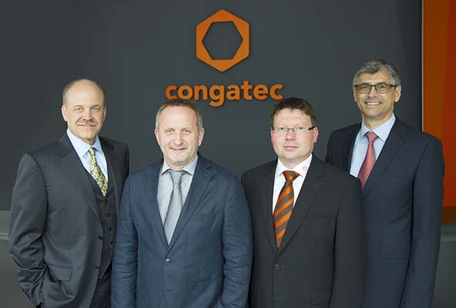
congatec's extended executive board: (from left) CEO Jason Carlson, CTO Gerhard Edi,
COO Matthias Klein and CFO Josef Wenzl.
Photo online at: http://www.congatec.com/press
Press release 09/2015
congatec AG expands executive board to help accelerate growth
Jason Carlson appointed CEO, with the support of Gerhard Edi as CTO, Josef Wenzl as CFO and Matthias Klein as COO

Deggendorf, Germany, July 1, 2015 * * * congatec AG, a leading technology and service provider for embedded computer boards and modules, announced that it has expanded its executive board to help accelerate growth and named Jason Carlson as the new CEO. Carlson, who will be based in the United States, will lead congatec as it continues to pursue its growth strategy.
Gerhard Edi, founding member of congatec AG and its CEO since 2007, stated: “The appointment of Jason Carlson fulfills my desire to bring in a new CEO, preferably American, with the experience we need to fulfill our next growth milestones. This allows me to focus on the CTO role within the executive board and enables me to continue to provide the leadership for congatec’s strategic and technological development.”
Mr. Carlson, who brings more than 25 years of experience in leading private and publicly held technology companies, stated: “It is an honor to become the CEO of such an innovative high-tech company. congatec has a clear focus, direction and mission in a dynamic and growing market. My mission now is to identify and coordinate internal and external growth opportunities, with the goal of elevating congatec from its present status as a European leader in embedded computer technologies to becoming a global player. With Gerhard Edi as CTO, Josef Wenzl as CFO and Matthias Klein as COO, I am very fortunate to have such strong and experienced partners in the executive board that complement my skills and who will support me in focusing on our growth strategies.”
Mr. Carlson joined the executive board (“Vorstand”) as CEO effective after congatec’s supervisory board meeting on June 23rd. His previous experience in leadership roles at public companies includes CEO of Semtech Corp., VP/GM at Cirrus Logic, Board member at Advanced Analogic Technologies, and Vicor Corp., where he is currently a Board member. Most recently he was CEO of QD Vision, and previously was CEO at Emo Labs and Audiologic Inc.
In the new role as CFO (“Vorstand Finanzen”), Josef Wenzl will strengthen the financial strategy with his experience in leading finance at congatec since 2010. Prior to joining congatec, Josef Wenzl served as Director Finance and Site General Manager at Force Computers, Motorola and Emerson.
About congatec AG
Headquartered in Deggendorf, Germany, congatec AG is a leading supplier of industrial computer modules using the standard form factors Qseven, COM Express, XTX and ETX, as well as single board computers and EDM services. congatec’s products can be used in a variety of industries and applications, such as industrial automation, medical technology, entertainment, transportation, telecommunication, test and measurement and point-of-sale. Core knowledge and technical know-how includes unique extended BIOS features as well as comprehensive driver and board support packages. Following the design-in phase, customers are given support via extensive product lifecycle management. The company’s products are manufactured by specialist service providers in accordance with modern quality standards. Currently congatec has entities in Taiwan, Japan, China, USA, Australia and the Czech Republic. More information is available on our website at www.congatec.com or via Facebook, Twitter and YouTube.

* * *

