Reader enquiries: | Press contact:
congatec AG | SAMS Network
Christian Eder | Michael Hennen
Phone: +49-991-2700-0 | Phone: +49-2405-4526720
info@congatec.com  www.congatec.com | info@sams-network.com  www.sams-network.com

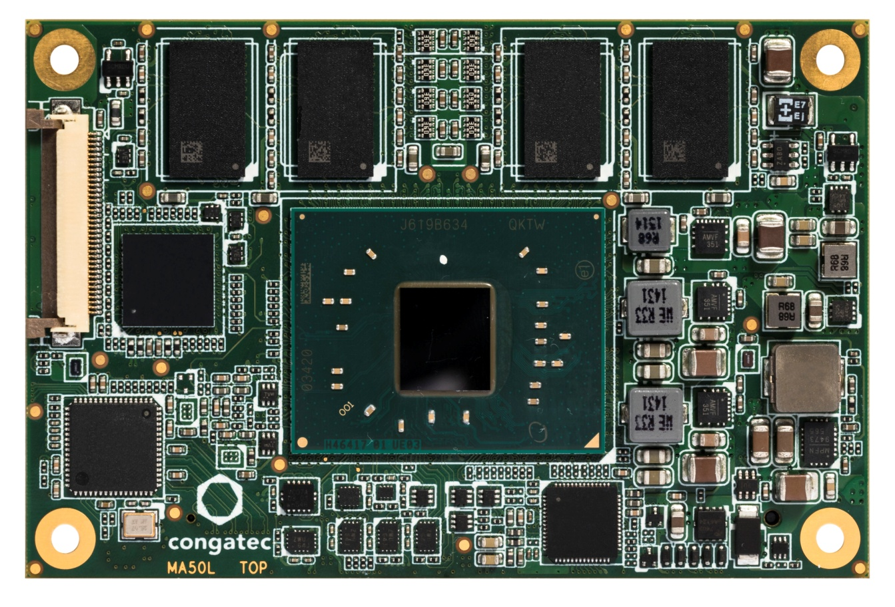
Text and photograph available at: http://www.congatec.com/press
New Product Introduction

congatec’s new COM Express Mini module with Intel Apollo Lake processors

Offers more than any credit card sized COM Express module before

Deggendorf, Germany, December 08, 2016 * * * congatec – a leading technology company for embedded computer modules, single board computers and embedded design and manufacturing services – has released the conga-MA5, the next generation of low-power modules for the industrial and extended temperature range in the credit card sized COM Express Mini form factor. The new COM Express Type 10 Computer-on-Modules are equipped with the latest Intel® Atom™, Celeron® and Pentium® processors (code name Apollo Lake) and impress with 30% more processing power and 45% more graphics performance on a very small COM Express Mini module.

Target applications can be found wherever a small footprint matters and where the rich eco system of COM Express is key for engineers, as is the case for handheld and rugged mobile applications as well as stationary mini devices and IoT gateways. Mobile devices benefit from approximately 15% longer battery life while connected industrial devices benefit especially from the enhanced real-time capabilities. Impressive for all applications is the massively improved graphics performance that now also includes the support of 4k displays.

“The launch of Type 10 modules rounds off congatec’s portfolio of boards and modules based on the impressive new Intel low-power processor technology. COM Express Compact Type 6 modules as well as Qseven and SMARC 2.0 modules were launched last month. Mini-ITX and Pico-ITX boards are also available as application-ready industrial single board computers. At congatec, engineers can find everything they need to simplify their use of the new Intel® Atom™, Celeron® and Pentium® processor technology in their embedded and IoT applications,” explains Christian Eder, Director Marketing at congatec.

The feature set in detail
The new credit card sized congatec COM Express Mini modules are available with the power saving Intel® Atom™ processors E3930, E3940 and E3950 for the extended temperature range of -40° C to +85° C, or are fitted with the more powerful low-power dual-core Intel® Celeron® N3350 and quad-core Intel® Pentium® N4200 processors. With up to 8 GB dual channel DDR3L RAM the modules offer best in class memory performance and significant bandwidth advantages compared to competing modules with only single channel memory. They also feature the high-performance Intel Gen9 graphics which provides up to 18 execution units to support up to 2 independent displays via single channel LVDS/eDP and the digital display interface for DP 1.2 or HDMI 1.4b. For IoT connectivity and generic extensions, there are 1x Gigabit Ethernet interface, 4x PCIe 2.0 lanes and 8 USB ports, two of which are provided as USB 3.0. Additional peripherals can be connected via 1x SPI, 1x LPC, 4x GPIO and 2x serial UART interfaces. For the storage media, up to 128 GB of on board flash memory with fast eMMC 5.1, or 2x 6 Gbps SATA are an option. Audio signals are carried via HDA.

Software support is provided for Microsoft Windows 10, including the Microsoft Windows 10 IoT versions and all current Linux operating systems. The Board Support Package will also include support for the latest Wind River IDP 3.1. Customized integration support, a comprehensive range of accessories including cooling solutions and an evaluation carrier board as well as optional Embedded Design & Manufacturing services for application specific carrier board and system designs are also available.

The new conga-MA5 COM Express Mini modules can be ordered in the following standard configurations:
Processor |  | Cores |  | Intel® Smart Cache [MB] |  | Clock/ Burst  [GHz] |  | TDP [W] |  | Graphics Execution Units
Intel® Pentium® N4200 |  | 4 |  | 2 |  | 1.1 / 2.5 |  | 6 |  | 18
Intel® Celeron® N3350 |  | 2 |  | 1 |  | 1.1 / 2.4 |  | 6 |  | 12
Intel® Atom™ x7-E3950 |  | 4 |  | 2 |  | 1.6 / 2.0 |  | 12 |  | 18
Intel® Atom™ x5-E3940 |  | 4 |  | 2 |  | 1.6 / 1.8 |  | 9 |  | 12
Intel® Atom™ x5-E3930 |  | 2 |  | 1 |  | 1.3 / 1.8 |  | 6.5 |  | 12

For more information about the new conga-MA5 COM Express Mini computer module visit: http://www.congatec.com/en/products/com-express-type10/conga-ma5.html

About congatec AG
Headquartered in Deggendorf, Germany, congatec AG is a leading supplier of industrial computer modules using the standard form factors COM Express, Qseven and SMARC as well as single board computers and EDM services. congatec’s products can be used in a variety of industries and applications, such as industrial automation, medical, entertainment, transportation, telecommunication, test & measurement and point-of-sale. Core knowledge and technical know-how includes unique extended BIOS features as well as comprehensive driver and board support packages. Following the design-in phase, customers are given support via extensive product lifecycle management. The company’s products are manufactured by specialist service providers in accordance with modern quality standards. Currently congatec has entities in Taiwan, Japan, China, USA, Australia, Czech Republic, United Kingdom and France,. More information is available on our website at www.congatec.com or via Facebook, Twitter and YouTube.

* * *

Intel and Intel Atom, Celeron, Pentium are registered trademarks of Intel Corporation in the U.S. and other countries.

