Press release

congatec COM-HPC Client modules with latest socketed Intel Core processors set performance record

Bringing a refreshing performance boost to the edge
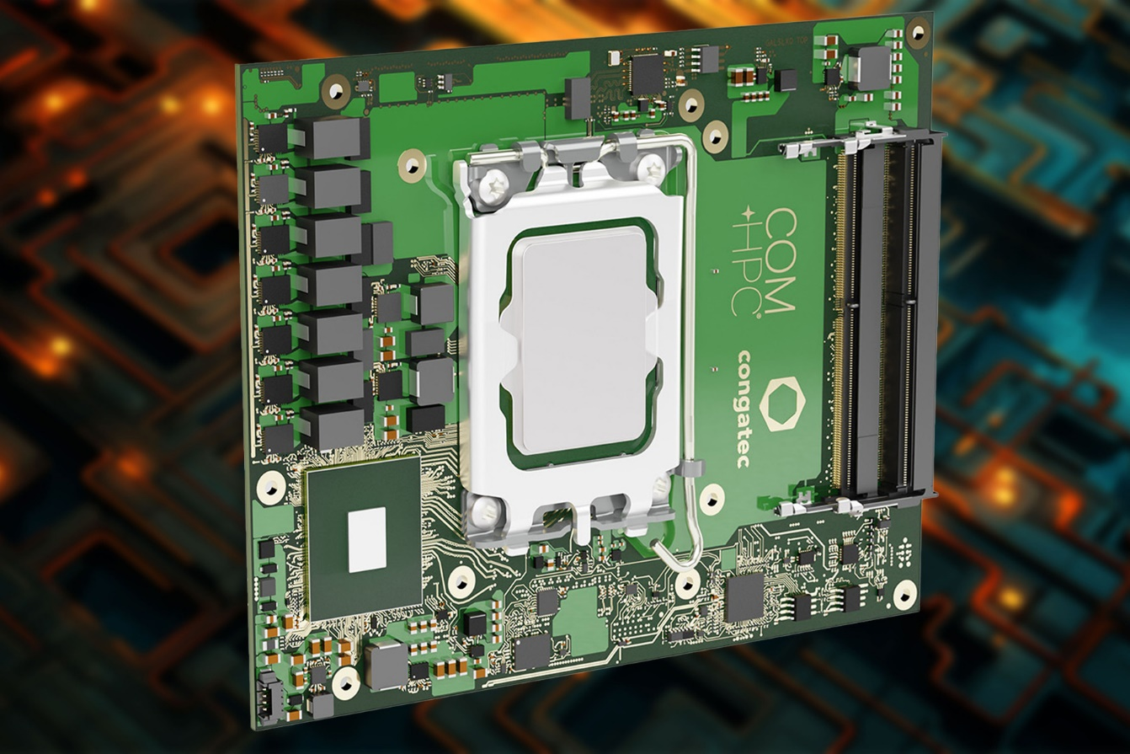

Deggendorf, Germany, 9 January 2024 * * * congatec – a leading vendor of embedded and edge computing technology – announces four new high-end COM-HPC Computer-on-Modules based on the 14th Generation Intel Core processors (codename Raptor Lake-S Refresh), which launched today. Representing an extension to the existing conga-HPC/cRLS Computer-on-Modules, the modules set new records for industrial workstations and edge computers in certain areas. Thanks to Intel's improved production quality, clock frequencies have been increased, resulting in performance gains across the entire range. The Intel Core i7-14700 processor-based modules stand out with four additional E-Cores compared to the Intel Core i7-13700E variants, providing an additional performance boost with now 20 cores in total. Another new feature is the improved bandwidth of USB 3.2 Gen 2x2 with up to 20 gigabits per second.

"The new conga-HPC/cRLS Computer-on-Modules represent one of the highest performance levels available on COM-HPC Client Size C and are chipset compatible with the existing modules based on Raptor Lake-S. This means that they can immediately provide existing designs with even more power," explains Jürgen Jungbauer, Senior Product Line Manager at congatec. “Suitable heat sinks for maximum performance boost are also available, allowing developers to find everything they need for integration into their dedicated systems in our high-performance ecosystem.”

The COM-HPC Size C form factor (120 mm x 160 mm) addresses application areas that require outstanding multi-core and multi-thread performance, large caches, enormous memory capacities combined with high bandwidth and advanced I/O technology. These include, for example, performance-hungry applications based on artificial intelligence (AI) and machine learning (ML). In addition, there are all embedded and edge computing solutions with workload consolidation, for which congatec offers pre-configured real-time hypervisor technology in the module firmware. The target markets for the new congatec COM HPC Size C Computer-on-Modules include industrial automation and medical technology as well as edge and network infrastructure applications. They all benefit from the optimized computing cores of this hybrid performance architecture, which currently supports up to 8 performance cores and 16 efficiency cores.

The new conga-HPC/cRLS Computer-on-Modules in COM-HPC Size C form factor are available in the below variants. All variants of the Intel Core 14xxx Series are new.

Processor |  | Cores/  (P + E) |  | Max. Turbo  Freq. [GHz]  P-cores/E-cores |  | Base Freq. [GHz]  P-cores/ E-cores |  | Threads |  | GPU Execution Units |  | CPU Base Power [W]
Intel Core i9-14900 |  | 24 (8+16) |  | 5.8 / 4.3 |  | 2.0 / 1.5 |  | 32 |  | 32 |  | 65
Intel Core i7-14700 |  | 20  (8+12) |  | 5.4 / 4.2 |  | 2.1 / 1.5 |  | 28 |  | 32 |  | 65
Intel Core i5-14400 |  | 10 (6+4) |  | 4.7 / 3.5 |  | 2.5 / 1.8 |  | 16 |  | 24 |  | 65
Intel Core i3-14100 |  | 4 (4+0) |  | 4.7 / - |  | 3.5 / - |  | 8 |  | 24 |  | 60
Intel Core i9-13900E |  | 24 (8+16) |  | 5.2 / 4.0 |  | 1.8 / 1.3 |  | 32 |  | 32 |  | 65
Intel Core i7-13700E |  | 16 (8+8) |  | 5.1 / 3.9 |  | 1.9 / 1.3 |  | 24 |  | 32 |  | 65
Intel Core i5-13400E |  | 10 (6+4) |  | 4.6 / 3.3 |  | 2.4 / 1.5 |  | 16 |  | 24 |  | 65
Intel Core i3-13100E |  | 4 (4+0) |  | 4.4 / - |  | 3.3 / - |  | 8 |  | 24 |  | 65

Application engineers can deploy the new COM-HPC Computer-on-Modules on congatec’s Micro-ATX Application Carrier Board (conga-HPC/uATX) for COM-HPC Client type modules to instantly capitalize on all the benefits and improvements of these modules in combination with ultrafast PCIe Gen5 connectivity.

For more information on the conga-HPC/cRLS Computer-on-Module in COM-HPC Size C form factor, its tailored cooling solutions, and congatec’s Module Services, please visit https://www.congatec.com/en/products/com-hpc/conga-hpccrls/

You can experience these and other innovations at embedded world from 9-11 April 2024: https://www.congatec.com/de/congatec/events/congatec-at-embedded-world-2024/
Visit congatec in Hall 3 at Stand 241.
* * *
About congatec
congatec is a rapidly growing technology company focusing on embedded and edge computing products and services. The high-performance computer modules are used in a wide range of applications and devices in industrial automation, medical technology, robotics, telecommunications and many other verticals. Backed by controlling shareholder DBAG Fund VIII, a German midmarket fund focusing on growing industrial businesses, congatec has the financing and M&A experience to take advantage of these expanding market opportunities. congatec is the global market leader in the computer-on-modules segment with an excellent customer base from start-ups to international blue chip companies. More information is available on our website at www.congatec.com or via LinkedIn, X (Twitter) and YouTube.

Text and photograph available at: https://www.congatec.com/en/congatec/press-releases.html

Intel, the Intel logo, and other Intel marks are trademarks of Intel Corporation or its subsidiaries.

Reader enquiries:
congatec
Phone: +49-991-2700-0
info@congatec.com
www.congatec.com

Press contact congatec:
congatec
Christof Wilde
Phone: +49-991-2700-2822
christof.wilde@congatec.com

Press contact agency:
Publitek GmbH
Julia Wolff
+49 (0)4181 968098-18
julia.wolff@publitek.com
Bremer Straße 6
21244 Buchholz
Germany

Please send print publications to:
Publitek GmbH
Diana Penzien
Bremer Straße 6
21244 Buchholz
Germany

