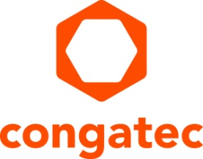
Press release

congatec showcases high-performance computing ecosystems for factory digitization

From AI to secure connectivity – innovative embedded platforms for smart factories
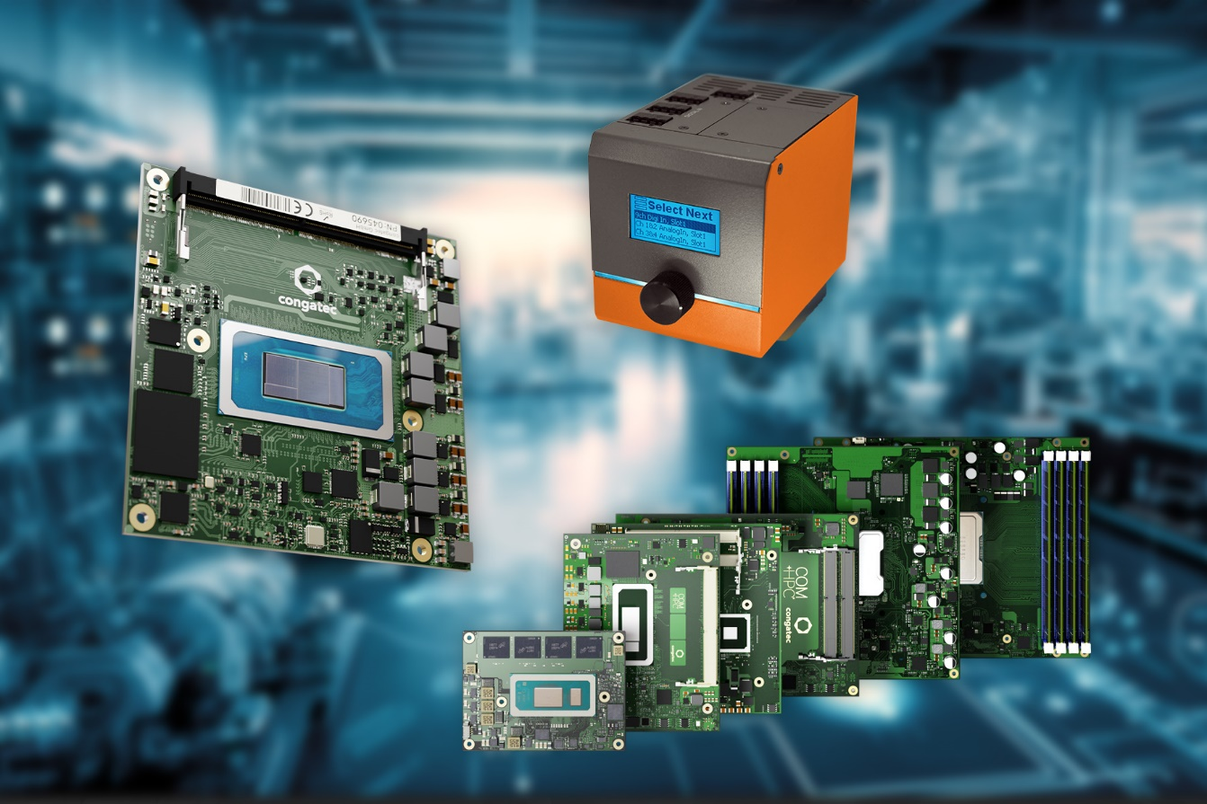

Taipei, Taiwan, 16 January 2024 * * * congatec – a leading vendor of embedded and edge computing technology – will showcase its high-performance ecosystems for factory digitization at Factory Innovation Week 2024 (Booth W54-70) in Tokyo, Japan, from January 24-26. Presentations will focus on advanced Computer-on-Modules as high-performance platforms for smart factory equipment and intelligent robotics applications, as well as rugged edge server designs and secure connectivity solutions for IT/OT convergence in smart factories.

Showcase highlight: High-performance COM-HPC ecosystem
The highlight of congatec’s showcase is a complete ecosystem of COM-HPC modules to enable high-performance edge applications. With the recent ratification of the COM-HPC 1.2 specification, COM-HPC is now the most scalable and powerful standard for a range of applications from low-power to high-end servers. The congatec COM-HPC Mini modules with 13th Gen Intel Core processors (codename Raptor Lake) represent a major benchmark for high-end embedded and edge computing at the client level. This small form factor standard allows even the most space-constrained solutions like autonomous mobile robots (AMRs) to benefit from a massive performance boost and significantly more high-speed interfaces. This enables the migration of entire product families to the new PICMG standard.

AI upgrade for the edge
Additionally, visitors can see congatec’s latest range of COM Express Compact modules based on Intel Core Ultra processors (code named Meteor Lake). Providing a unique mix of heterogeneous compute engines, these new modules are ideal to run demanding AI workloads at the edge. With the integrated Intel AI Boost neural processing unit (NPU), it has never been easier to integrate artificial intelligence in x86-based systems. Target applications for the new Intel Core Ultra processor-based Computer-on-Modules are smart factory applications requiring high-performance real-time computing with powerful AI capabilities. Examples include inspection systems, stationary robotic arms and autonomous mobile robots (AMRs).

Secure IoT edge connector
congatec is also unveiling a new digitization solution platform that covers the entire smart factory journey – from initial production process digitization to direct data use and further processing at the edge. The IoT edge connector enables secure OT/IT connectivity and can consolidate OT systems across different production sections or locations.

It comes as a compact, application-ready system for industrial use and provides a flexible physical interface selection. The system is easy to configure without programming, and the individual solution modules require only simple parameterization before they can be used. This makes it ideal for machine builders looking for a flexible digitization solution, as well as for system integrators and manufacturers.

For more information on congatec’s presentations at Factory Innovation Week 2024, Tokyo Big Sight, Booth W54-70, January 24-26, please visit: https://www.congatec.com/en/congatec/events/factory-innovation-week/

* * *
About congatec
congatec is a rapidly growing technology company focusing on embedded and edge computing products and services. The high-performance computer modules are used in a wide range of applications and devices in industrial automation, medical technology, transportation, telecommunications and many other verticals. Backed by controlling shareholder DBAG Fund VIII, a German midmarket fund focusing on growing industrial businesses, congatec has the financing and M&A experience to take advantage of these expanding market opportunities. congatec is the global market leader in the Computer-on-Modules segment with an excellent customer base from start-ups to international blue-chip companies. More information is available on our website at www.congatec.com or via LinkedIn, X and YouTube.

Intel, the Intel logo, and other Intel marks are trademarks of Intel Corporation or its subsidiaries.

Reader enquiries:
congatec
Crysta Lee
Phone: +886 2 25978577
info@congatec.com
www.congatec.com

Press contact congatec:
congatec
Christof Wilde
Phone: +49-991-2700-2822
christof.wilde@congatec.com

