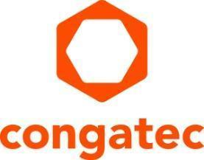
Press release

congatec launches new product family aReady.COM, the first key stage of its aReady. strategy

The goal: Fitting computer-on-modules with everything that application developers need

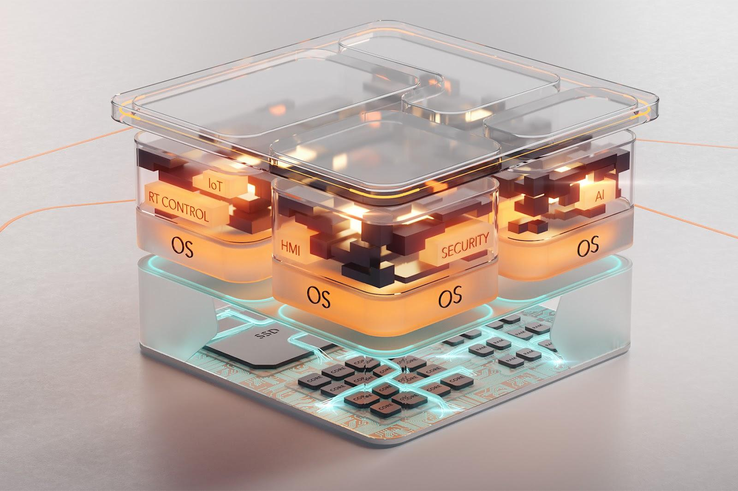

San Diego, CA, March 13th 2024 * * * congatec – a leading provider of embedded and edge computing technology – launches new product family aReady.COM, the first key stage of its innovative aReady. strategy, which offers significantly smoother implementation of embedded and edge computing technology with the assistance of high-performance embedded building blocks, ranging from Computer-on-Modules (COM) to cloud. congatec’s new aReady.COMs integrate application-ready hypervisor, operating system and IIoT software configurations that customers can put together according to their individual requirements. Developers can boot these individually configured aReady.COMs straight away and then install their applications. This means that the complexity of the integration work below the application layers and for the diverse IIoT functionalities of an embedded and edge computing system is reduced to a minimum. The first aReady.COMs are available with the ctrlX OS from Bosch Rexroth. More aReady. products are to follow.

For customers, aReady.COMs mean that they can count on computer-on-modules in a function-validated complete package, the application-readiness of which extends to the virtualisation, OS, and software layer, to which OEMs can seamlessly connect their applications. aReady.COMs decouple system development from application development to the highest degree, resulting in significantly faster time-to-market because OEMs can focus completely on application development.

“Our aReady. strategy is congatec’s innovative approach for simplifying the implementation and use of modern basic technologies over the entire life cycle of customer applications. This will raise “application-readiness” as a mark of quality to a whole new level. Moreover, it is not just limited to COMs but even covers everything from COM to cloud. Computer-on-modules from congatec and all the services that we offer for it have always been geared towards making the integration of our embedded and edge computing technologies as easy as possible for developers. Our aReady.COM means that we are establishing a new premium level for this application readiness. It makes the use of our modules even more convenient and efficient, because the software building blocks required, both below and alongside the customer application are provided by congatec in application-ready form in the required configuration and function-validation,” explains Tim Henrichs, Vice President Marketing & Business Development at congatec.

“The seamless integration of our hypervisor technology, and our growing portfolio of industrial software along with the integration of operating systems such as ctrlX OS, represent the first key stage of our aReady. strategy. Our roadmap also includes a whole host of further fully configurable, application-ready hardware, software and service building blocks, covering everything up to cloud solutions for device management and maintenance. The most important point about all these aReady. products is that they will be an integral component of computer-on-modules, are fully function-validated and are pre-configured to individual requirements from a single source. This kind of comprehensive portfolio for system design can otherwise only be found in dedicated solutions at system level. What we are doing, though, is positioning this solution portfolio much earlier in the value-added chain and therefore making it available for the entire community of embedded and edge computing developers,” explains Andreas Bergbauer, Manager Solution Management at congatec.

The feature set in detail
In terms of hardware, application-ready aReady.COMs offer a hypervisor integrated in the firmware and an integrated memory on which the operating system(s) and IIoT applications are pre-installed to individual requirements. If, for example, the Linux-based ctrlX OS operating system from Bosch Rexroth is used, the entire ctrlX OS World is also opened up automatically, along with the extensive app portfolio of the ctrlX Store for PLC applications, motion control and communication, as well as engineering tools. Developers can also access a wide range of IoT and cloud apps, including key functions such as firewalls and VPN clients.

For the evaluation of the aReady.COM portfolio, customers can currently choose between two computer-on-modules on the basis of the COM-HPC standard: The COM-HPC conga-aCOM/mRLP Mini Module and the performance-oriented COM-HPC conga-aCOM/cRLP Client Size A Module, both based on the 13th Generation Intel Core processor series (code name "Raptor Lake"). Their software building blocks are application-ready and can be freely combined/configured to provide customers with an adapted subsystem which is precisely tailored to their specific requirements. The current portfolio includes the hypervisor for system consolidation, the IIoT software for device management, security, multi-site networking and databases, as well as the complete Bosch Rexroth ctrlX OS ecosystem. congatec will be progressively expanding this portfolio. In future, therefore, customers will be able to choose from the entire congatec module portfolio and obtain an even wider choice of high-performance building blocks.

Further information about the aReady. strategy and the enhanced feature set of the new aReady.COMs from congatec is available at: https://www.congatec.com/en/aready/

You can experience these and other innovations at embedded world from April 9th-11th 2024: https://www.congatec.com/de/congatec/events/congatec-at-embedded-world-2024/
Visit congatec in Hall 3 at Stand 241.

* * *

Please make a note of the press conference on all the latest news about congatec on April 9th from 2 - 2:30pm in the NCC east. An invitation will follow shortly. Please contact us directly if you are interested in joining the press conference and/or a one-to-one meeting at the stand.

About congatec
congatec is a rapidly growing technology company focusing on embedded and edge computing products and services. The high-performance computer modules are used in a wide range of applications and devices in industrial automation, medical technology, robotics, telecommunications and many other verticals. Backed by controlling shareholder DBAG Fund VIII, a German midmarket fund focusing on growing industrial businesses, congatec has the financing and M&A experience to take advantage of these expanding market opportunities. congatec is the global market leader in the computer-on-modules segment with an excellent customer base from start-ups to international blue chip companies. More information is available on our website at www.congatec.com or via LinkedIn, X (Twitter) and YouTube.

Text and photograph available at: https://www.congatec.com/en/congatec/press-releases.html

Intel, the Intel logo, and other Intel marks are trademarks of Intel Corporation or its subsidiaries.

Reader Enquiries:
congatec
Farhad Sharifi
Phone: 858-457-2600
Farhad.Sharifi@congatec.com
www.congatec.us

Press Contact:
congatec
Janene Rae
Phone: 858-457-2600
janene.rae@congatec.com
www.congatec.us

PR Agency:
Publitek GmbH
Julia Wolff
+49 (0)4181 968098-18
julia.wolff@publitek.com
Bremer Straße 6
21244 Buchholz

Please send print publications to:
Publitek GmbH
Diana Penzien
Bremer Straße 6
21244 Buchholz

