Press release

congatec welcomes publication of COM-HPC Carrier Design Guide Rev. 2.2

COM-HPC Mini specification is now complete

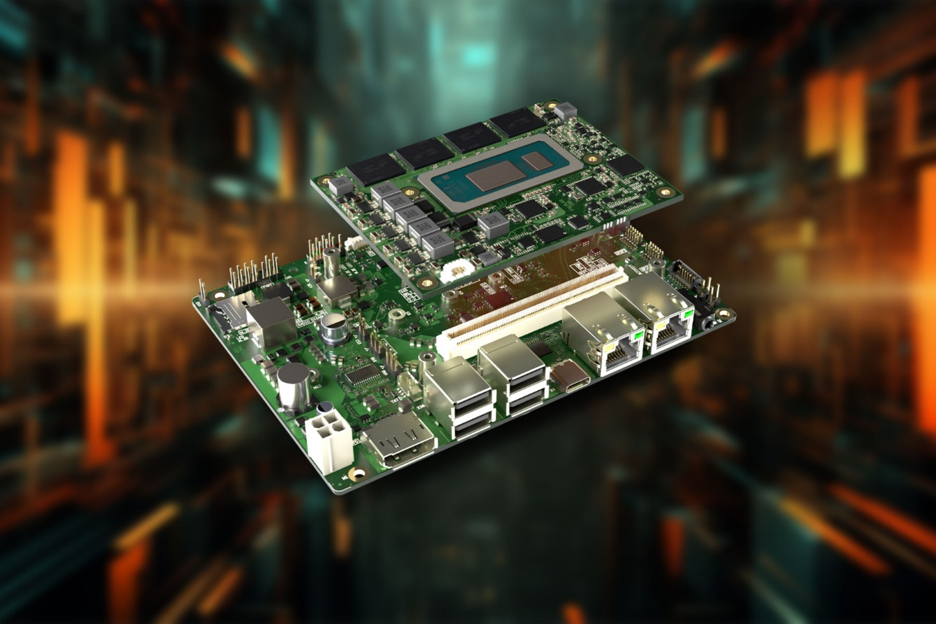

Deggendorf, Germany, 21 March, 2024 * * * congatec – a leading provider of embedded and edge computing technology – welcomes the publication of COM-HPC Carrier Design Guide Rev. 2.2, which provides developers with performance specifications and a source of inspiration for the layout of modular designs on the basis of the small 95 mm x 70 mm COM-HPC Mini specification. The guide, published by the manufacturer-independent standards organisation PICMG, provides developers of embedded systems with comprehensive guidelines for the design of COM-HPC Mini-based carrier boards and also covers all new features and interfaces which have been implemented with the latest update to the COM-HPC specification. The availability of this new guide is absolutely critical for the embedded computing community, as high-performance designs need this guide in order to be able to migrate existing COM Express-based designs to the COM-HPC Mini specification (COM HPC specification 1.2) which was officially adopted in October 2023.

With 400 pins, COM-HPC Mini provides significantly more pins for interfaces than the module standards in Mini format available to date and also supports the latest high-speed interfaces – including PCIe 4.0 / PCIe 5.0, 10 Gbit/s Ethernet, USB 4.0, Thunderbolt and much more. The maximum input power of 76 W also provides plenty of latitude for high-performance multicore processors such as the 13th Gen Intel® Core™ processor series (code name "Raptor Lake-P") with up to 14 cores, which congatec already offers on the COM-HPC Mini modules of the conga-HPC/mRLP series. They support, among other things, firmware-integrated hypervisor technology to enable parallel tasks to be carried out in virtual machines on a non-reactive basis, which aids system consolidation.

A change in the COM-HPC design principles has an impact on the overall height of the module and heat spreader, reduced by 5 mm for COM-HPC Mini compared to COM-HPC Client designs. As a result, the minimum installation height required is now just 15 mm instead of the 20 mm normally required from the top of the carrier board under the other COM-HPC specifications. This makes very slim designs possible, of the kind required for mobile hand-held devices or panel PCs. To meet the height limits, COM-HPC Mini modules have soldered memories in all cases. This makes COM-HPC Mini modules inherently rugged, as soldered memories provide not only greater resistance to shock and vibration but efficient cooling as well through direct thermal coupling to heat spreaders.

Customers who would like support in implementing the details of the design guide can obtain sample layouts from congatec and take part in design-in training courses. congatec provides assistance with the selection of components and offers services for signal integrity simulation and for the checking of the layout so that problems can be identified at an early stage. congatec also offers engineering support as an option for the speedy provision of first prototypes.

Download the new COM-HPC Design Guide 2.2:
https://www.picmg.org/resources/design-guides/

The key features of the COM-HPC Mini specification can be found at: https://www.congatec.com/en/technologies/com-hpc-mini/

The first COM-HPC Mini module:
https://www.congatec.com/en/products/com-hpc/conga-hpcmrlp/
congatec module services:
https://www.congatec.com/en/technologies/technical-services/

You can experience these and other innovations at embedded world from April 9th -11th 2024:
https://www.congatec.com/de/congatec/events/congatec-at-embedded-world-2024/
Visit congatec in Hall 3 at Stand 241.
* * *

Please make a note of the press conference on all the latest news about congatec on April 9th from 2 - 2:30pm in the NCC east. An invitation will follow shortly. Please contact us directly if you are interested in joining the press conference and/or a one-to-one meeting at the stand.

About congatec
congatec is a rapidly growing technology company focusing on embedded and edge computing products and services. The high-performance computer modules are used in a wide range of applications and devices in industrial automation, medical technology, robotics, telecommunications and many other verticals. Backed by controlling shareholder DBAG Fund VIII, a German midmarket fund focusing on growing industrial businesses, congatec has the financing and M&A experience to take advantage of these expanding market opportunities. congatec is the global market leader in the computer-on-modules segment with an excellent customer base from start-ups to international blue chip companies. More information is available on our website at www.congatec.com or via LinkedIn, X (Twitter) and YouTube.

Reader enquiries:
congatec
Phone: +49-991-2700-0
info@congatec.com
www.congatec.com

Press contact congatec:
congatec
Christof Wilde
Phone: +49-991-2700-2822
christof.wilde@congatec.com

Press contact agency:
Publitek GmbH
Julia Wolff
+49 (0)4181 968098-18
julia.wolff@publitek.com
Bremer Straße 6
21244 Buchholz

Please send print publications to:
Publitek GmbH
Diana Penzien
Bremer Straße 6
21244 Buchholz

Intel, the Intel logo, and other Intel marks are trademarks of Intel Corporation or its subsidiaries.

