Press release

congatec introduces new SMARC modules with TI Jacinto™ 7 TDA4x or DRA8x processors

High-end edge AI and vision processing in ultra-low power envelop

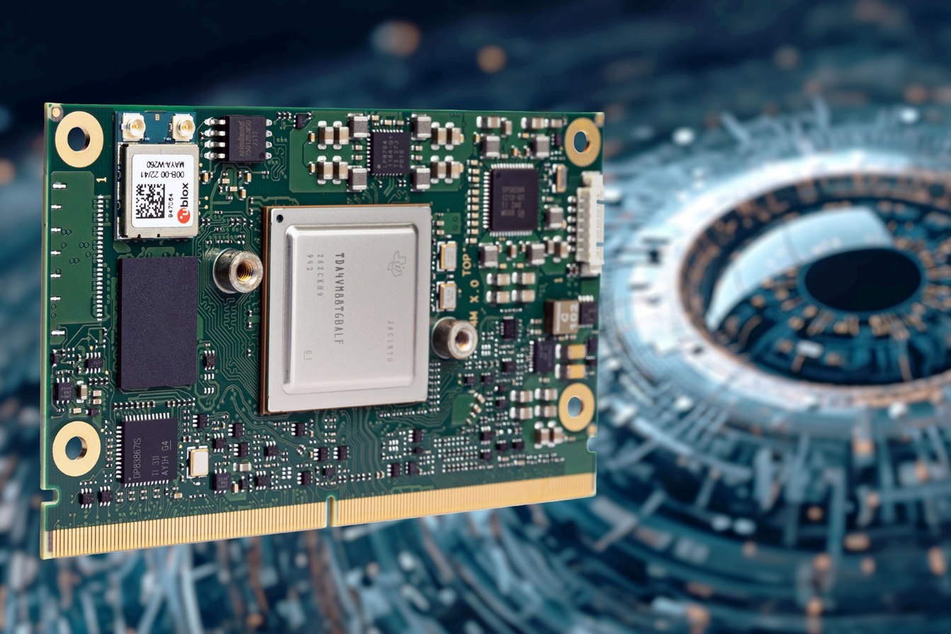

Deggendorf, Germany, 28 September 2023 * * * congatec - a leading vendor of embedded and edge computing technology - has announced the launch of its latest SMARC Module 2.1 Computer-on-Modules based on Texas Instruments Jacinto™ 7 TDA4x or DRA8x processors. These new industrial-grade Computer-on-Modules are ideal for high-performance AI edge applications with an ultra-low power (ULP) envelope featuring dual Arm Cortex-A72 processors, powerful AI accelerators, and 3D graphics. The conga-STDA4 modules consuming only 5 to 10 Watt, target industrial mobile machinery that requires 2d/3d camera, radar, and lidar based near-field analytics, such as automated guided vehicles (AGVs) and autonomous mobile robots (AMRs), as well as applications in construction and agricultural machinery. They are also suitable for any vision-focused industrial automation or medical solutions that require powerful and energy-efficient AI processing at the edge.

The new SMARC modules come with two MIPI CSI camera inputs. The TDA4x processor based conga-STDA4 adds an Image Signal Processor (ISP), vision accelerators, and pre-trained AI models from the TI Model Zoo, allowing for a seamless start into AI-powered application development. Additionally, it includes a Robotic SDK for enhanced functionality. The DRA8x variants offer a cost-efficient option without vision processing accelerators. Designed to withstand harsh industrial environments, both high-throughput module variants support the extended temperature range from -40 °C to +85 °C, as well as Time-Sensitive Networking (TSN), and cybersecurity measures.

“By integrating the powerful Texas Instruments Jacinto™ 7 TDA4x and TI DRA8x processors in our high-performance SMARC Module 2.1 ecosystem, congatec simplifies the design-in process for this advanced Arm Cortex-A72 based SoC technology. This allows vision-based situational awareness designers in various embedded industries to focus on their core competencies, saving upfront costs and reducing time to market, especially for industrial quantity production”, explains Martin Danzer, Director of Product Management at congatec. Industrial OEMs, particularly those without time and financial resources for full custom designs, can benefit from the innovative SMARC high-performance ecosystem offered by congatec. It streamlines the design process while ensuring high design security and low non-recurring engineering (NRE) costs.
The feature set in detail
The new congatec conga-STDA4 Computer-on-Modules based on the SMARC Module 2.1 specification are equipped with Texas Instruments Jacinto™ 7 TDA4VM or DRA829J processors based on 2 Arm Cortex-A72 and 6 Arm Cortex-R5F. With 2x MIPI-CSI 4-lanes and integrated Image Signal Processor (ISP) for MIPI-CSI cameras, the new modules enable high-quality camera, lidar, or radar data capture and processing. Featuring Deep-learning Matrix Multiply Accelerators (MMA) with up to 8 TOPS and C7x floating-point vector DSP with up to 80 GFLOPs, the module delivers exceptional performance for deep learning and AI processing. Exclusive to the Jacinto™ 7 TDA4VM variant are the Vision Processing Accelerators (VPAC) with Image Signal Processor (ISP) and multiple vision assist accelerators ensuring high-quality image processing and analysis. Common to both processor variants are the Depth and Motion Processing Accelerators (DMPAC) to enable accurate depth perception and motion tracking. Graphics performance including GPGPU capabilities are enhanced with the integrated Graphics Accelerator 3D GPU PowerVR Rogue 8XE GE8430. The new modules are embedded in congatec’s high-performance SMARC 2.1 Module ecosystem featuring tailored cooling solutions, evaluation and application ready carrier boards as well as value-adding services including signal compliance testing, conformal coating, and design-in trainings.

The new conga-STDA4 SMARC Computer-on-Modules based on Texas Instruments Jacinto™ 7 TDA4V and DRA8 processors support Linux, QNX, RTOS, and VxWorks and are available in the following standard configurations, with customization options available upon request:

 | Processor | ARM Cortex-A72 | ARM Cortex-R5F | DSP Cores / GFLOPs | VPAC / DMPAC
 | TI TDA4VM | 2 | 6 | 1x C7x / 80  2x C66 / 40 | Yes
 | TI DRA829J | 2 | 6 | 1x C7x / 80  2x C66 / 40 | No

For more information about congatec's new conga-STDA4 SMARC modules and its capabilities, please visit: https://www.congatec.com/en/products/smarc/conga-STDA4/

* * *
About congatec
congatec is a rapidly growing technology company focusing on embedded and edge computing products and services. The high-performance computer modules are used in a wide range of applications and devices in industrial automation, medical technology, robotics, telecommunications, and many other verticals. Backed by controlling shareholder DBAG Fund VIII, a German midmarket fund focusing on growing industrial businesses, congatec has the financing and M&A experience to take advantage of these expanding market opportunities. congatec is the global market leader in the computer-on-modules segment with an excellent customer base from start-ups to international blue chip companies. More information is available on our website at www.congatec.com or via LinkedIn, and YouTube.

Reader enquiries:
congatec
Phone: +49-991-2700-0
info@congatec.com
www.congatec.com

Press contact congatec:
congatec
Christof Wilde
Phone: +49-991-2700-2822
christof.wilde@congatec.com

Press contact agency:
Publitek GmbH
Julia Wolff
+49 (0)4181 968098-18
julia.wolff@publitek.com
Bremer Straße 6
21244 Buchholz

Please send print publications to:
Publitek GmbH
Diana Penzien
Bremer Straße 6
21244 Buchholz

