Press release

congatec to showcase enhanced edge-computing landscape that saves OEMs from cost-intensive groundwork at Automation World Korea

Solution platforms for high-performance engineering

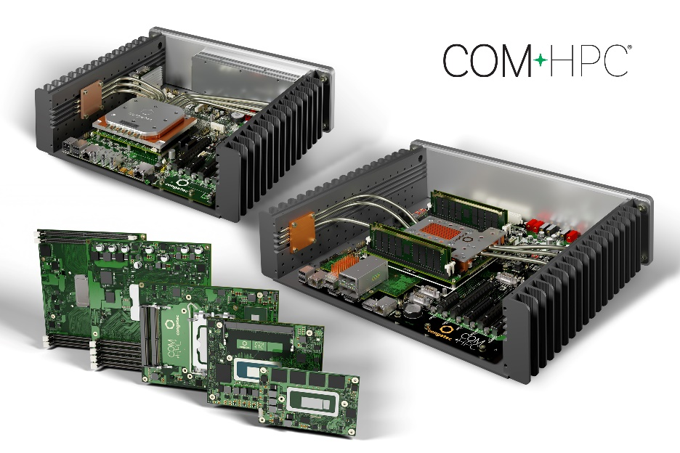

Seoul, Korea / Taipei City, Taiwan, March 2, 2023 * * * congatec – a leading vendor of embedded and edge computing technology – will be presenting its enhanced high-performance landscape for edge computing at Automation World Korea (hall C, booth 534). This ecosystem empowers OEMs in the automation and machine building markets to rapidly bring their solutions to the next levels of computing performance, artificial intelligence (AI), IoT connectivity, real-time responsiveness, security, user experience (UX), and cost savings through hardware consolidation. Highlights of the congatec showcase are the new high-performance COM-HPC Computer-on-Modules ecosystem alongside solutions platforms for smart vision in cooperation with Hacarus and Basler; artificial intelligence in cooperation with Hailo, building a complete high-performance landscape. Utilizing such application-ready edge computing platforms, compiled by strong ecosystem partners who are all leading in their sectors, frees OEMs from doing labor- and cost-intensive groundwork, thereby accelerating product engineering and time to market.

New COM-HPC Computer-on-Modules
The presented portfolio ranges from high-performance COM-HPC Server-on-Modules to ultra-compact and brand-new COM-HPC Client-on-Modules that are hardly larger than a credit card. Together with matching and tailored cooling solutions, carrier boards, and design-in services, congatec now provides everything designers need for their next generation of high-performance embedded and edge computing platforms to accelerate the digital transformation. And with the new COM-HPC Mini standard, even the most space-constrained solutions can benefit from a high-performance boost and a significantly larger number of new high-speed interfaces with the congatec portfolio. Thus, OEMs can migrate entire product families to the new PICMG standard – without significant modification of the internal system design and housing. Two reference system designs demonstrate how easy it is for OEMs to get their applications productive faster by using pre-validated and proven system concepts that can be adapted more quickly to their specific needs instead of developing everything from scratch.

- The embedded edge server flagship of the COM-HPC presentations is a reference system design with heat pipe cooling for harsh industrial environments. It is based on the conga-HPC/sILH Server-on-Modules with Intel Xeon D processors (codenamed Ice Lake D) and offers advanced networking capabilities with 8x 25Gb Ethernet. With up to 20 cores it is predestined for workload consolidation in production cells as well as for orchestrating communications in IoT network infrastructures. Other use cases include data aggregators and secure gateways between OT and IT. Support for Real-Time Systems' real-time hypervisor technology also enables mixed-critical application scenarios.

- For industrial workstation performance, congatec presents a robust COM-HPC client reference system design based on the conga-HPC/cRLP Client-on-Modules with 13 Gen Intel Core processors with up to 14 cores. Typical use cases of this fanless design are high-performance applications with real-time control, artificial intelligence, HMI visualization and edge gateway functionalities, all running on a single platform.

Further information on congatec’s COM-HPC offerings can be found at:
https://www.congatec.com/en/technologies/com-hpc/

Artificial intelligence in cooperation with Hailo
In a brand-new cooperation with AI processor vendor Hailo, congatec presents a demo with 4 cameras connected to the 3.5-in single board computer (SBC) conga-JC370 hosting one Hailo-8 AI module. Featuring up to 26 tera-operations per second (TOPS), the Hailo-8 edge AI processor significantly outperforms all other edge AI processors. Compared to other leading solutions, its area and power efficiency are superior by a considerable order of magnitude – at a size smaller than a penny, even including the required memory. With an architecture that takes advantage of the core properties of neural networks, the neural chip allows edge devices to run deep learning applications at full scale more efficiently, effectively, and sustainably than other AI chips and solutions, while significantly lowering costs. Hosted on an application-ready 3.5-in SBC equipped with deep-learning pre-trained modules for various computer vision tasks, engineers can rapidly create prototypes on this new AI platform.

Smart vision in cooperation with Hacarus and Basler
The smart vision showcase compiled in cooperation with the Japanese AI experts at Hacarus consists of an efficient Sparse Modeling Kit based on machine learning algorithms. Sparse modeling needs little training data to make highly accurate predictions. This is an advantage for vision-based inspection systems, among others, because the reject rate is naturally lower when manufacturing quality is high. With sparse modeling it is possible to create a new inspection model starting with 50 or even fewer images. This is significantly less than the 1,000 or more images required for traditional AI. The Sparse Modeling Kit can be used stand-alone or as an add-on to existing inspection systems. Primary customers are vision system providers and system integrators. Another group of users includes machine and system builders who want to use vision-based AI in their devices but have been reluctant to do so up to now, because the wide variety of individual customer installations requires algorithms to be adapted, which was previously too costly.
Further information on the benefits of sparse modeling can be found in this Whitepaper.
https://www.congatec.com/en/technologies/sparse-modeling-slim-but-powerful-artificial-intelligence-for-embedded-systems/
* * *

About congatec
congatec is a rapidly growing technology company focusing on embedded and edge computing products and services. The high-performance computer modules are used in a wide range of applications and devices in industrial automation, medical technology, transportation, telecommunications and many other verticals. Backed by controlling shareholder DBAG Fund VIII, a German midmarket fund focusing on growing industrial businesses, congatec has the financing and M&A experience to take advantage of these expanding market opportunities. congatec is the global market leader in the computer-on-modules segment with an excellent customer base from start-ups to international blue chip companies. More information is available on our website at www.congatec.com or via LinkedIn, Twitter and YouTube.

Text and photograph available at: https://www.congatec.com/en/congatec/press-releases.html

Intel, the Intel logo, and other Intel marks are trademarks of Intel Corporation or its subsidiaries. All other trademarks are property of their respective owners.

Reader enquiries:
congatec
Crysta Lee
Phone: +886 2 25978577
info@congatec.com
www.congatec.com

Press contact:
SAMS Network
Michael Hennen
Phone: +49-2405-4526720
congatec@sams-network.com
www.sams-network.com

Please send print publications to:
SAMS Network
Sales And Management Services
Michael Hennen
Zechenstraße 29
52146 Würselen
Germany

Please send links to digital publications to:
office@sams-network.com

