Press release

congatec introduces high-performance COM-HPC carrier board in Micro-ATX form factor

Modular high-end Micro-ATX carrier for more sustainable and ultra-scalable COM-HPC based system designs

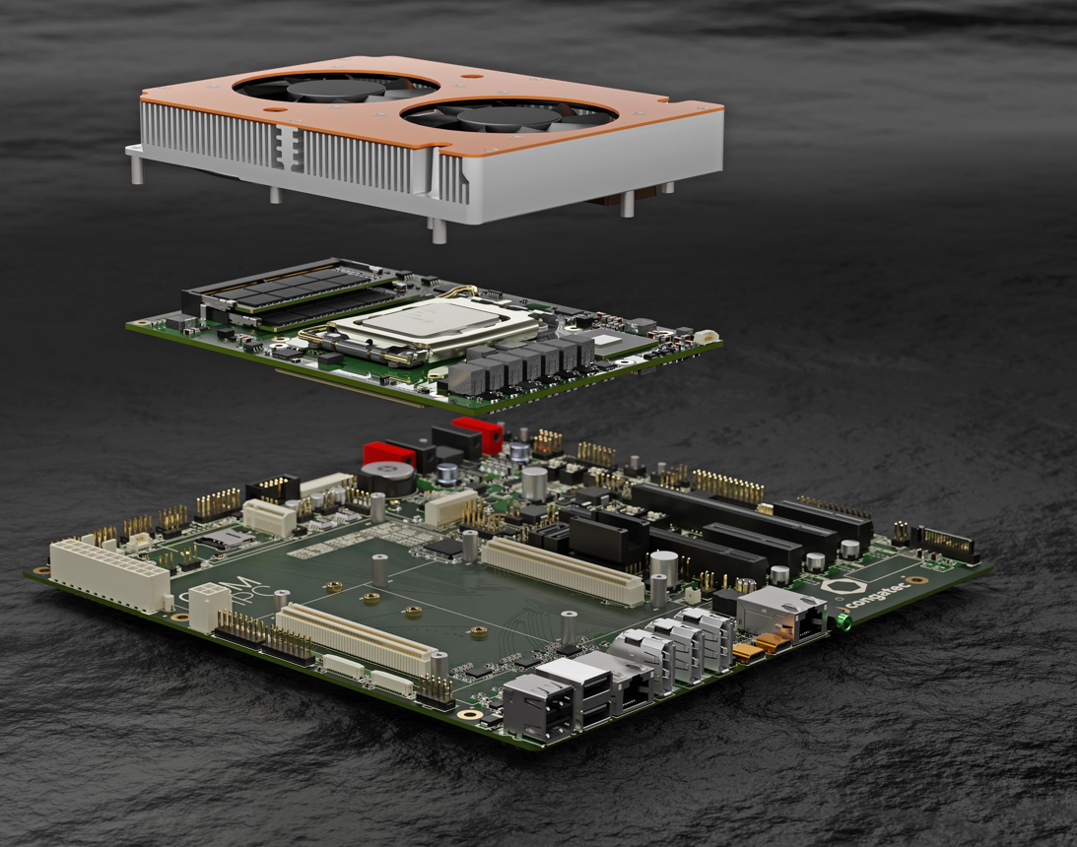

Deggendorf, Germany, 26 July 2022 * * * congatec – a leading vendor of embedded and edge computing technology – enters the high-end industrial workstation and desktop client market by introducing its first modular Micro-ATX compliant carrier board with COM-HPC interface. The board is designed for embedded long-term availability of at least seven years, which eliminates the design risks, revision requirements and supply chain uncertainties of standard or semi-industrial-grade motherboards that are usually only deliverable for three to five years. As it is processor socket and vendor independent, the board can be equipped with any high-end Computer-on-Module available in COM-HPC Client Size A, B or C, making OEM designs even more flexible and sustainable. Impressive scalability across the entire range of 12th Generation Intel Core processor-based COM-HPC modules, which congatec offers in 14 different high-end performance flavors, is just the start of possibilities. Performance options for the new conga-HPC/uATX carrier board range from the conga-HPC/cALS COM-HPC Client Size C modules, offering the currently highest embedded client performance with 16-core Intel Core i9 processor, to the masters of price/performance optimization – the conga-HPC/cALP COM-HPC Client Size A modules with Intel Celeron 7305E processor.

The combination of application-ready industrial-grade COMs & carrier boards with tailored cooling solutions and comprehensive BSPs for all leading RTOSes and the real-time hypervisor from Real-Time Systems is perfect for fastest time-to-market, produces lowest non-recurring engineering costs, enables customers to react very quickly to changing market requirements and reduces the effort to scale the performance of Micro-ATX based systems to a minimum. It allows customers to create a full product portfolio based on one single carrier concept.

Future upgrade and update options of Micro-ATX based platforms are design-inherent, which delivers a maximum of performance flexibility, system design security and sustainable long-term availability for application-specifically customized carrier board and system designs. In times of supply chain uncertainties, the option to pick any available COM-HPC module is a particular advantage. OEMs benefit from not being tied to one specific BGA or LGA processor from a single silicon or Computer-on-Modules vendor, which reduces the supply shortage risk significantly. At the same time, the mechanics and application-specific peripherals can stay as they are without needing any hardware changes.

“The new industrial-grade COM-HPC carrier board in Micro-ATX form factor ports all benefits of Computer-on-Modules to the high-end industrial and semi-industrial motherboard market. It will progress conventional motherboard based system designs, which are tailored to a certain processor generation, to far more flexibly and sustainably scalable motherboard layouts that utilize Computer-on-Modules. Industrial applications need longer life cycles than three to five years to reduce the NRE costs and to maximize the return on investment of dedicated systems. Being able to switch the processor performance to any future option without the need to re-build the entire system is thus a huge advantage for many industries,” explains Martin Danzer, Director Product Management at congatec.

The new conga-HPC/uATX carrier board for COM-HPC Computer-on-Modules in Micro-ATX form factor enables engineers to instantly prototype the next generation of their high-performance embedded and edge computing systems for fastest time to market. Application areas of Micro-ATX system designs are system solutions that support multiple displays and can be found in various markets. Typical applications range from industrial and medical HMIs, real-time edge controllers, industrial PCs and control room systems to infotainment and digital signage applications all the way up to professional casino gaming systems.

The carrier board offers the latest interface enhancements such as PCIe Gen4 and USB 4 and is a perfect fit for system designs with congatec’s latest high-end COM-HPC Client modules based on the 12th generation Intel Core i9/7/5/3 desktop processors (formerly code-named Alder Lake-S). Most impressive is the fact that engineers can now leverage Intel’s innovative performance hybrid architecture. Offering of up to 16 cores/24 threads, 12th Gen Intel Core processors provide a quantum leap in multitasking and scalability levels.

Next-gen IoT and edge applications benefit from up to 8 optimized Performance-cores (P-cores) plus up to 8 low power Efficient-cores (E-cores) and DDR5 memory support to accelerate multithreaded applications and execute background tasks more efficiently. Optimized for highest embedded client performance, the graphics of the LGA processor based modules delivers now up to 94% faster performance and its image classification inference performance has nearly tripled with up to 181% higher throughput. In addition, the modules offer massive bandwidth to connect discrete GPUs for maximum graphics and GPGPU based AI performance.

Besides highest bandwidth and performance, the new flagship COM-HPC Client modules impress with dedicated AI engines supporting Windows ML, Intel Distribution of OpenVINO toolkit and Chrome Cross ML. The different AI workloads can seamlessly be delegated to the P-cores, E-cores, as well as the GPU execution units to process even the most intensive edge AI workloads. The built-in Intel Deep Learning boost technology leverages different cores via Vector Neural Network Instructions (VNNI), and the integrated graphics supports AI accelerated DP4a GPU instructions that can even be scaled to dedicated GPUs. Furthermore, Intel’s lowest power built-in AI accelerator, the Intel Gaussian & Neural Accelerator 3.0 (Intel GNA 3.0), enables dynamic noise suppression and speech recognition and can even run while the processor is in low power states for wake-up voice commands.

The conga-HPC/cALS COM-HPC Client Size C modules with 12th Gen Intel Core desktop processors will be available in the following 4 configurations:

Processor |  | Cores/  (P + E) |  | P-cores  Freq. [GHz] |  | E-cores  Freq. [GHz] |  | GPU Compute Units |  | CPU Base Power [W]
conga-HPC/cALS-i9-12900E |  | 16 (8+8) |  | 2.3 / 5.0 |  | 1.7 / 3.8 |  | 32 |  | 65
conga-HPC/cALS-i7-12700E |  | 12 (8+4) |  | 2.1 / 4.8 |  | 1.6 / 3.6 |  | 32 |  | 65
conga-HPC/cALS-i5-12500E |  | 6 (6+0) |  | 2.9 / 4.5 |  | - / - |  | 32 |  | 65
conga-HPC/cALS-i3-12100E |  | 4 (4+0) |  | 3.2 / 4.2 |  | - / - |  | 24 |  | 60

For the lower end of high-end desktop clients, 10 more variants with soldered processors are available on conga-HPC/cALP COM-HPC Client Size A modules (95x120mm).

The Micro-ATX carrier board design can be adapted to OEM demands and carrier board schematics are available upon request. Engineers who want to learn how to design carrier boards with COM-HPC Computer-on-Modules are welcome to participate in COM-HPC trainings offered by congatec.

Engineers can easily compile their starter set for field deployments by ordering the new conga-HPC/uATX carrier board for COM-HPC Computer-on-Modules in Micro-ATX form factor, choosing one of congatec’s COM-HPC Client Computer-on-Modules plus appropriate cooling solutions tailored to the specific module, and order the demanded congatec validated DRAM in the same package. Support for Real-Time Systems’ hypervisor technology as well as OS support for Real-Time Linux and Wind River VxWorks makes these starter sets a truly rounded ecosystem package to facilitate and accelerate the development of edge computing applications.

For deeper insight into the entire feature set of this brand new Micro-ATX motherboard-sized COM-HPC carrier board, please visit the products website: https://www.congatec.com/en/products/accessories/conga-HPC-uATX

To find suitable COM-HPC modules for this new Micro-ATX motherboard-sized COM-HPC carrier board, please visit either https://www.congatec.com/en/products/com-hpc/conga-hpccals/ for the modules with socketed 12th Gen Intel Core processors; or https://www.congatec.com/en/products/com-hpc/conga-hpccalp/ for the BGA soldered 12th Gen Intel Core processor variants.

For information about future performance scalability of the Micro-ATX motherboard-sized COM-HPC carrier board, please contact sales@congatec.com to receive a personal presentation of congatec’s COM-HPC Client roadmap. For certain information, a NDA will be required.
* * *

About congatec
congatec is a rapidly growing technology company focusing on embedded and edge computing products and services. The high-performance computer modules are used in a wide range of applications and devices in industrial automation, medical technology, transportation, telecommunications and many other verticals. Backed by controlling shareholder DBAG Fund VIII, a German midmarket fund focusing on growing industrial businesses, congatec has the financing and M&A experience to take advantage of these expanding market opportunities. congatec is the global market leader in the computer-on-modules segment with an excellent customer base from start-ups to international blue chip companies. More information is available on our website at www.congatec.com or via LinkedIn, Twitter and YouTube.

Reader enquiries:  congatec  Christian Eder  Telefon: +49-991-2700-0  info@congatec.com  www.congatec.com | Press contact:  SAMS Network  Michael Hennen  Telefon: +49-2405-4526720  congatec@sams-network.com  www.sams-network.com

Text and photograph available at: https://www.congatec.com/en/congatec/press-releases.html

Intel, the Intel logo, and other Intel marks are trademarks of Intel Corporation or its subsidiaries.

