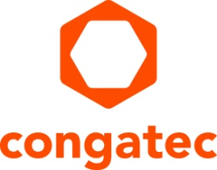
Press release

congatec introduces vehicle computing technology for smart mobility at Intertraffic Amsterdam

Embedded computing engines that put smart vehicle developers into the fast lane

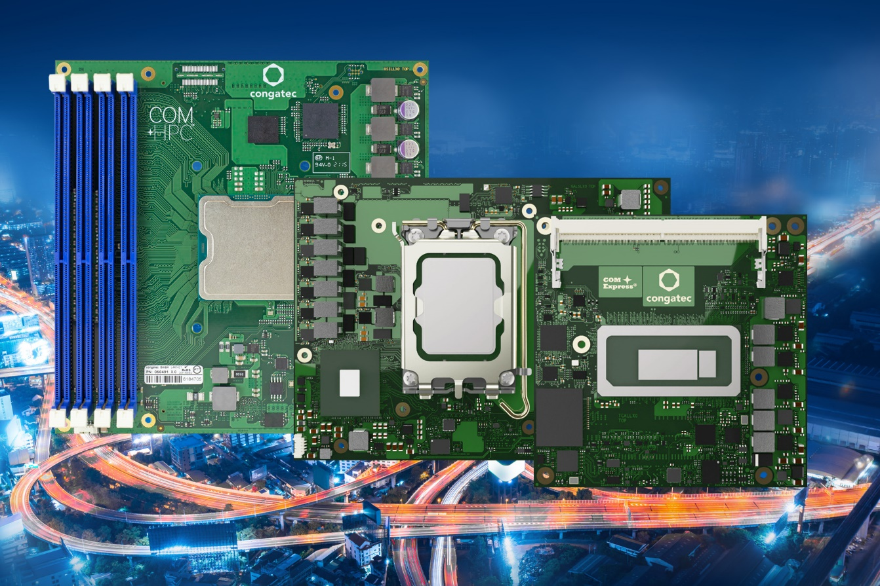

Amsterdam, March 29, 2022 * * * congatec – a leading vendor of embedded and edge computing technology – is pleased to introduce new rugged vehicle computing platforms for smart mobility applications in the extended temperature range at Intertraffic Amsterdam, Hall 5/Booth 309. Designed to simplify and accelerate digitization and autonomous driving in harsh environments such as transportation, logistics, construction, and agriculture, congatec’s smart mobility solutions range from computing platforms for the next generation of real-time 5G connected, unmanned, functionally safe vehicles to solutions designed for digitizing the mobility kinematics of existing fleets. The goal is to provide highly accurate orientation data to improve situational awareness, and ultimately to optimize the movement and operation of autonomous vehicles.

Mobility OEMs and their tier 1 suppliers must tackle a variety of tasks when designing the next generation of smart autonomous mobility controllers: They have to integrate vision and various other sensors for gathering situational raw data, plus implement data preprocessing and artificial intelligence (AI) to improve data analytics, and design controller logic for autonomous vehicle movement and operation. As if all that wasn’t enough, they also need 5G network sliced device connectivity for vehicle-to-vehicle and vehicle-to-x communication. And all this needs to be implemented with real-time capabilities and functional safety.

“congatec positions itself as the embedded computing platform and ecosystem provider that supports OEMs and their tier 1 suppliers comprehensively in all these tasks, from TSN capable rugged Computer-on-Modules for the extended temperature ranges and real-time hypervisor technologies to application ready OEM platforms provided by solution partners such as Etteplan,” says Christian Eder, Director Marketing at congatec.

Highlights of the congatec presentations at Intertraffic Amsterdam are the Intel Xeon D processor based COM-HPC Server modules for edge servers in autonomous railway applications and 5G wayside equipment; the 12th Gen Intel Core processor based COM-HPC Client and COM Express modules for smart vehicle gateways and vehicle network controllers; as well as an application ready, Intel Atom processor based real-time kinematic platform by congatec’s solution partner Etteplan.

Real-time kinematic platform
Based on congatec Computer-on-Modules, the real-time kinematic Etteplan platform features an RTK-enabled GNSS unit with accelerometer, gyroscope and magnetometer and is designed for automotive voltage ranges up to 36V. The Intel Atom processor based system supports a wide operating temperature range of -40°C to +85°C and provides IP65/67 protection. For connectivity towards the vehicle communication networks, it offers extensions for real-time Ethernet (TSN), RS232, RS485 and CAN. Further edge connectivity options include Wi-Fi and Bluetooth as well as LTE/5G. Ambient pressure, humidity and temperature sensors round off the feature set. The platform is available as a prototype that can be ordered immediately for solution engineering purposes. For larger quantities, customization is possible on a project basis. The standard system platform is scheduled to go into series production in the second half of 2022.

COM-HPC Server modules with Intel Xeon D processors
The new COM-HPC Server modules in Size E and Size D with Intel Xeon D processors are designed to accelerate the next generation of real-time microserver workloads in rugged vehicle and mobility environments with extended temperature ranges. Improvements include up to 20 cores, up to 1 TB RAM, double throughput per PCIe lane compared to Gen 4, as well as up to 100 GbE connectivity and TCC/TSN support. Target use cases in traffic applications range from outdoor servers deployed in 5G tactile internet applications to edge servers in trains plus vision based public and infrastructure safety applications. More information about the new Intel Xeon D processor based Computer-on-Modules can be found at: https://www.congatec.com/en/technologies/intel-xeon-d-modules/

Computer-on-Modules with 12th Gen Intel Core processors
Featuring 12th Generation Intel Core processors, the new congatec modules in COM-HPC Size A and Size C as well as COM Express Type 6 form factors offer major performance gains and improvements for the next generation of smart mobility systems. Most impressive is the fact that engineers can now leverage Intel’s innovative performance hybrid architecture. With up to 14 cores on BGA variants, 12th Gen Intel Core processors provide a quantum leap in multitasking and scalability to accelerate multithreaded vehicle applications and to execute dedicated real-time tasks more efficiently. In addition, with up to 96 Execution Units, the integrated Intel Iris Xe graphics is estimated to deliver extraordinary improvements of up to 129% in GPGPU processing to accelerate parallelized workloads such as AI algorithms, as compared to 11th Gen Intel Core processors. More information about the new 12th Gen Intel Core processor based Computer-on-Modules can be found at: https://www.congatec.com/en/technologies/intel-alder-lake-modules/
* * *

About congatec
congatec is a rapidly growing technology company focusing on embedded and edge computing products and services. The high-performance computer modules are used in a wide range of applications and devices in industrial automation, medical technology, transportation, telecommunications and many other verticals. Backed by controlling shareholder DBAG Fund VIII, a German midmarket fund focusing on growing industrial businesses, congatec has the financing and M&A experience to take advantage of these expanding market opportunities. congatec is the global market leader in the computer-on-modules segment with an excellent customer base from start-ups to international blue chip companies. More information is available on our website at www.congatec.com or via LinkedIn, Twitter and YouTube.

Reader enquiries:  congatec GmbH  Christian Eder  Phone: +49-991-2700-0  info@congatec.com  www.congatec.com | Press contact:  SAMS Network  Michael Hennen  Phone: +49-2405-4526720  info@sams-network.com  www.sams-network.com

Text and photograph available at: https://www.congatec.com/en/congatec/press-releases.html

Intel, the Intel logo, and other Intel marks are trademarks of Intel Corporation or its subsidiaries.

