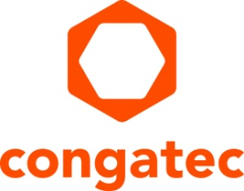
Press release

congatec introduces Computer-on-Modules for collaborative 5G robots and material handling systems at Smart Factory & Automation World

TSN synchronized real-time over 5G

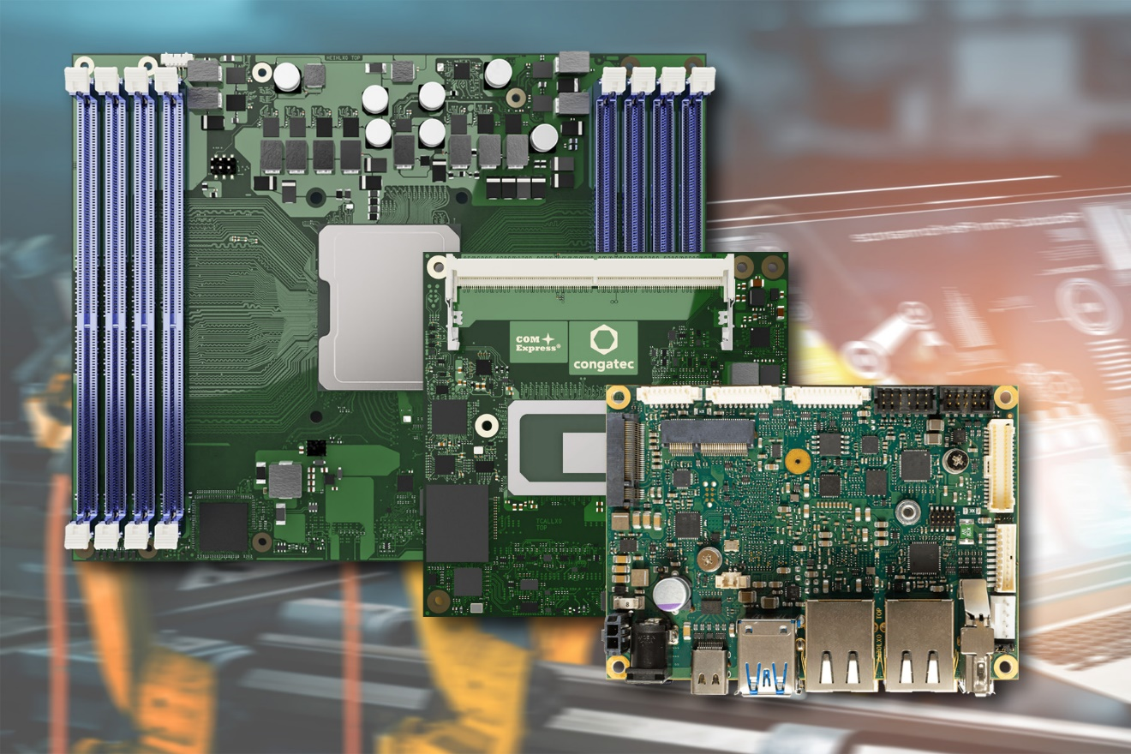

Seoul, Korea, April 6, 2022 * * * congatec – a leading vendor of embedded and edge computing technology – is pleased to introduce new Computer-on-Modules for 5G connected smart factories and industrial automation at Smart Factory & Automation World, Coex Hall C, Booth C522. Designed to simplify and accelerate the development of collaborative robotics and material handling systems, the smart mobility platforms from congatec are suitable for deployment in outdoor temperatures from -45°C to +85°C. Typical targets for these platforms range from next generation of real-time connected, functionally safe self-driving vehicles, to smart manufacturing and material handling applications ranging from collaborative and cooperative robots to substitutive solutions such as robots for THT assembly of PCB boards.

OEM vendors of next generation smart logistics vehicles and manufacturing robots must tackle a variety of tasks when designing those new controllers. They have to integrate vision and various other sensors for gathering situational raw data, need to implement data preprocessing and artificial intelligence (AI) to improve data analytics, and design controller logic for autonomous vehicle movement and operation. In addition, they need 5G device connectivity for vehicle-to-vehicle and vehicle-to-x communication, or respectively, robot-to-robot and robot-to-x-communication. And all this needs to be implemented with real-time capabilities and functional safety.

“congatec positions itself as the embedded computing platform and ecosystem provider that supports smart logistics vehicle and manufacturing robot vendors comprehensively in all these tasks, from TSN capable rugged Computer-on-Modules for the extended temperature ranges and real-time hypervisor technologies to application ready OEM platform building blocks provided by our constantly expanding network of solution partners,” says Yoonsun Kim, country manager at congatec Korea.

Highlights of the congatec presentations at Smart Factory & Automation World are the Intel Xeon D processor based COM-HPC Server modules for industrial edge servers and 5G campus network equipment; the 12th Gen Intel Core processor based COM-HPC Client and COM Express modules for smart vehicle/robot gateways and vehicle/robot network controllers; as well as Intel Celeron, Pentium and Atom processor based Pico-ITX Single Board Computers (SBCs) as application ready real-time processing cores for industrial edge computing applications.

COM-HPC Server modules with Intel Xeon D processors
The new COM-HPC Server modules in Size E and Size D with Intel Xeon D processors are designed to accelerate the next generation of real-time microserver workloads in industrial factories and outdoor environments with extended temperature ranges. Improvements include up to 20 cores, up to 1 TB RAM, double throughput per PCIe lane compared to Gen 3, as well as up to 100 GbE connectivity and TCC/TSN support. Target use cases in smart factory applications range from servers deployed in 5G tactile internet applications to edge servers for larger machines and manufacturing equipment. More information about the new Intel Xeon D processor based Computer-on-Modules can be found at: https://www.congatec.com/en/technologies/intel-xeon-d-modules/

Computer-on-Modules with 12th Gen Intel Core processors
Featuring 12th Generation Intel Core processors (formerly codenamed Alder Lake), the new congatec modules in COM-HPC Size A and Size C as well as COM Express Type 6 form factors offer major performance gains and improvements for the next generation of smart mobility systems and collaborative manufacturing robots. Most impressive is the fact that engineers can now leverage Intel’s innovative performance hybrid architecture. With up to 14 cores on BGA variants, 12th Gen Intel Core processors provide a quantum leap in multitasking and scalability to accelerate multithreaded vehicle and robotic applications and to execute dedicated real-time tasks more efficiently. In addition, with up to 96 Execution Units, the integrated Intel Iris Xe graphics is estimated to deliver extraordinary improvements of up to 129% in GPGPU processing to accelerate parallelized workloads such as AI algorithms, as compared to 11th Gen Intel Core processors. More information about the new 12th Gen Intel Core processor based Computer-on-Modules can be found at: https://www.congatec.com/en/technologies/intel-alder-lake-modules/

Pico-ITX Single Board Computers with Intel Atom x6000E processors
The Pico-ITX boards with Intel Atom x6000E Series processors or Intel Celeron and Pentium N & J Series processors (code named “Elkhart Lake”) are designed for edge-connected embedded systems. They impress with graphics performance up to three simultaneous displays running at 4kp60 and impressive multi-thread computing power on up to 4 cores. Further benefits especially welcomed in real-time industrial markets are Time Sensitive Networking (TSN), Intel Time Coordinated Computing (Intel TCC) and Real Time Systems (RTS) hypervisor support as well as BIOS configurable ECC and extended temperature options from -40°C to +85°C. The combination of rugged real-time operation, real-time connectivity and real-time hypervisor technologies is what OEMs need for IoT-connected industrial applications. More information about the conga-PA7 Pico-ITX Single Board Computers can be found at: https://www.congatec.com/en/products/pico-itx/conga-pa7/

* * *

About congatec
congatec is a rapidly growing technology company focusing on embedded and edge computing products and services. The high-performance computer modules are used in a wide range of applications and devices in industrial automation, medical technology, transportation, telecommunications and many other verticals. Backed by controlling shareholder DBAG Fund VIII, a German midmarket fund focusing on growing industrial businesses, congatec has the financing and M&A experience to take advantage of these expanding market opportunities. congatec is the global market leader in the computer-on-modules segment with an excellent customer base from start-ups to international blue chip companies. More information is available on our website at www.congatec.com or via LinkedIn, Twitter and YouTube.

Reader enquiries:  congatec GmbH  Christian Eder  Phone: +49-991-2700-0  info@congatec.com  www.congatec.com | Press contact:  SAMS Network  Michael Hennen  Phone: +49-2405-4526720  info@sams-network.com  www.sams-network.com

Text and photograph available at: https://www.congatec.com/en/congatec/press-releases.html

Intel, the Intel logo, and other Intel marks are trademarks of Intel Corporation or its subsidiaries.

