Reader enquiries: | Press contact:
congatec AG | SAMS Network
Christian Eder | Michael Hennen
Phone: +49-991-2700-0 | Phone: +49-2405-4526720
info@congatec.com  www.congatec.com | info@sams-network.com  www.sams-network.com

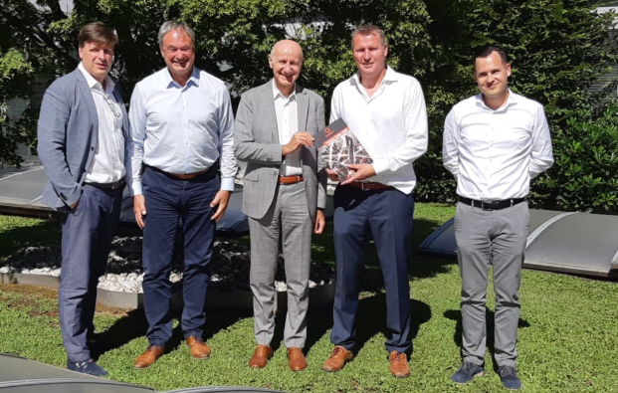
From left: Marcelo Soares (Management Director Schurter Italy), Roland Judith (Sales Director EMEA congatec),
Antonello Martegani (Managing Director Schurter Italy) Diethard Fent (Manager Sales Partner congatec),
Denny Amberger (Sales Partner Manager congatec)
Text and photograph available at: https://www.congatec.com/en/congatec/press-releases.html
Press release
congatec signs SCHURTER to extend its Italian sales partner network

SCHURTER adds world-leading
computer module vendor to its line card

Deggendorf, Germany, 30 October 2020 * * * congatec – a leading vendor of embedded and edge computing technology – is expanding its Italian sales partner network by entering into a distribution agreement with SCHURTER Electronics S.p.A., a member of the SCHURTER Group. In partnership with congatec, the SCHURTER line card now incorporates the embedded computing portfolio of the worldwide leader in the field of x86 and ARM Computer-on-Modules. Next to the very latest SMARC, Qseven, COM Express and COM-HPC modules, the portfolio also includes the entire range of accessories and comprehensive services provided by congatec.

“The distribution agreement with SCHURTER aims to significantly increase congatec’s presence in the Italian market. By adding another highly professional sales partner, we will grow and widen the reach of our offerings in this important region,” explains Denny Amberger, Sales Partner Manager EMEA at congatec AG. “Small and medium sized enterprises are one of the driving forces of the Italian economy and frequently demonstrate a capacity for innovation and flexibility that is unmatched in other sectors. SCHURTER is specialized in supporting those customers comprehensively – not only with the most suitable product lines and products, but also helping them find application solutions that allow them to leverage economies-of-scale as well as high quality series production.”

For customer designs, SCHURTER not only bundles the most diverse electronic components, but also enriches its offering with services from design-in through to system integration on the basis of Computer-on-Modules as the central processing unit.

“SCHURTER Electronics S.p.A. is positioning itself more and more as a leading Italian provider of embedded and edge computing solutions that are designed on the basis of the best components the market has to offer. With this in mind, we need to build partnerships with leading component vendors such as the embedded and edge computing expert congatec who, as the worldwide leader in COMs, provides a high-quality product portfolio and comprehensive services. Our added value is the deep knowledge of the market, the intimate relationship with our customers, and a brand that also has a worldwide reputation for high quality. We strongly believe that our mutual synergies will generate a significantly improved offering that will lead to an enlargement of the customer base and ultimately strengthen the brand recognition of both companies,” says Antonello Martegani – Managing Director at SCHURTER Electronics S.p.A.

congatec’s distribution agreement with SCHURTER Electronics S.p.A. comes into force immediately.

About congatec
congatec is a rapidly growing technology company focusing on embedded and edge computing products. The high-performance computer modules are used in a wide range of applications and devices in industrial automation, medical technology, transportation, telecommunications and many other verticals. Backed by controlling shareholder DBAG Fund VIII, a German midmarket fund focusing on growing industrial businesses, congatec has the financing and M&A experience to take advantage of these expanding market opportunities. congatec is the global market leader in the computer-on-modules segment with an excellent customer base from start-ups to international blue chip companies. Founded in 2004 and headquartered in Deggendorf, Germany, the company reached sales of 126 million US dollars in 2019. More information is available on our website at www.congatec.com or via LinkedIn, Twitter and YouTube.

* * *

