Reader enquiries: | Press contact:
congatec AG | SAMS Network
Christian Eder | Michael Hennen
Phone: +49-991-2700-0 | Phone: +49-2405-4526720
info@congatec.com  www.congatec.com | info@sams-network.com  www.sams-network.com

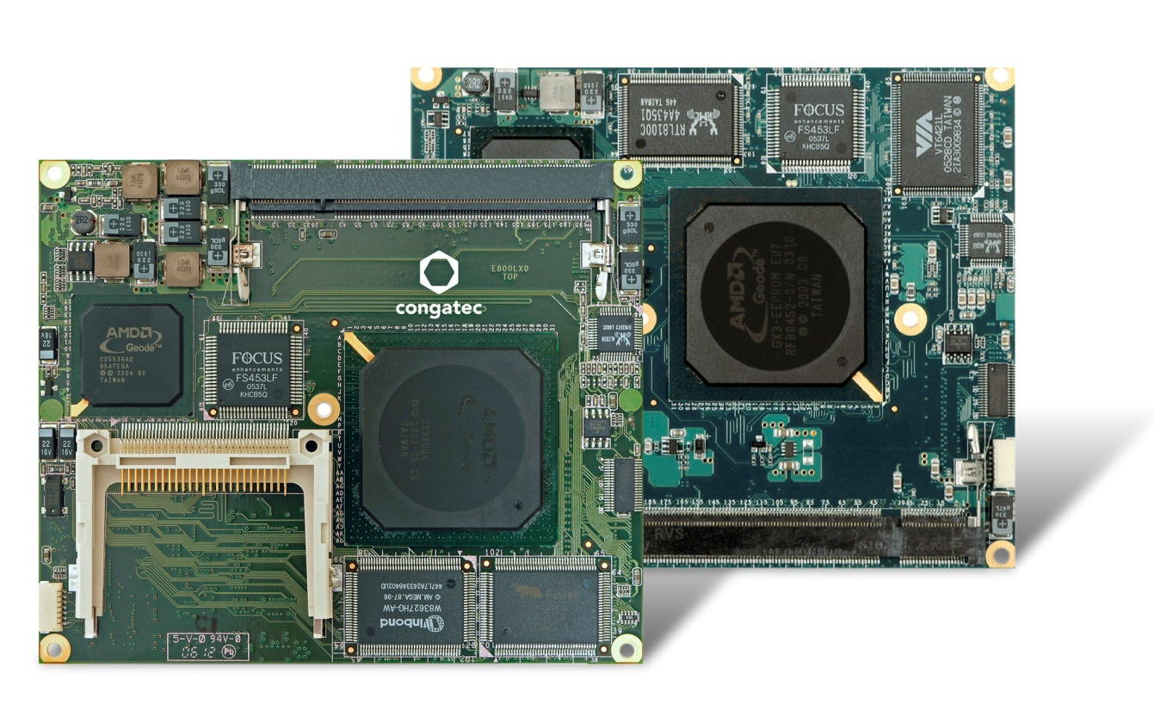
congatec sets new score with long-term support until 2021 for AMD Geode processor based ETX and XTX computer modules (from left)
Text and photograph available at: http://www.congatec.com/press

Press release

congatec partners with AMD for long-time support of
AMD Geode™ processors

A trustful team: congatec ETX/XTX modules and AMD Geode

Deggendorf, Germany, 16 January 2018 * * * congatec – a leading technology company for embedded computer modules, single board computers and embedded design and manufacturing services – and AMD have teamed together to provide extended life cycle support for one of the world's longest-serving x86 processors. The result is that AMD Geode™ processor boards from congatec will have planned availability until the end of 2021.

“With the collaboration between congatec and AMD to support the AMD Geode processor line on ETX and XTX modules at least until end of life in 2021, our Computer-on-Module customers benefit from massive life cycle and return on investment improvements for their AMD Geode based product lines,” explains Martin Danzer, Director Product Management at congatec. “Supply until 2021 means 16 years long-term availability for the Geode LX, which was introduced by AMD in 2005. This is unique to the embedded x86 processor markets, where processors in general are available for 7 years, and underlines our commitment to being a trusted partner for the entire product life cycle.”

“AMD has been serving the embedded market for over 20 years and from this experience we know that one of the most important things to customers is longevity of the supply chain channel,” says Stephen Turnbull, Director of Business Development, at AMD. “We are very proud that our Geode embedded product line is so successful that we can now extend the support to until at least 2021, making it one of the longest continuously available x86 embedded products on the market.”

In order to enable this extension, AMD has qualified a non-halogenated substrate with virtually no changes to processor form, fit or function so that all AMD qualification criteria will be met. congatec modules with the new Geode processor samples are available now under identical product order numbers.

The following products are supported:
Module |  | Form factor |  | Processor |  | RAM |  | Power consumption
conga-XLX |  | XTX |  | AMD Geode™ LX 800 |  | 1 GB DDR3/PC2700 |  | 5 W (typical)
conga-ELX |  | ETX |  | AMD Geode™ LX 800 |  | 1 GB PC2700 |  | 5 W (typical)
conga-ELXeco |  | ETX |  | AMD Geode™ LX 800 |  | 256 MB DRAM |  | 5 W (typical)

More information about the conga-XLX Computer-on-Modules can be found on the product page http://www.congatec.com/en/products/xtx/conga-xlx.html

More information about the conga-ELX Computer-on-Modules can be found on the product page http://www.congatec.com/en/products/etx.html

About congatec AG
Headquartered in Deggendorf, Germany, congatec AG is a leading supplier of industrial computer modules using the standard form factors COM Express, Qseven and SMARC as well as single board computers and EDM services. congatec’s products can be used in a variety of industries and applications, such as industrial automation, medical, entertainment, transportation, telecommunication, test & measurement and point-of-sale. Core knowledge and technical know-how includes unique extended BIOS features as well as comprehensive driver and board support packages. Following the design-in phase, customers are given support via extensive product lifecycle management. The company’s products are manufactured by specialist service providers in accordance with modern quality standards. Currently congatec has entities in USA, Taiwan, China, Japan and Australia as well as United Kingdom, France, and the Czech Republic. More information is available on our website at www.congatec.com or via Facebook, Twitter and YouTube.

About AMD
For more than 45 years AMD has driven innovation in high-performance computing, graphics and visualization technologies ― the building blocks for gaming, immersive platforms, and the datacenter. Hundreds of millions of consumers, leading Fortune 500 businesses and cutting-edge scientific research facilities around the world rely on AMD technology daily to improve how they live, work and play. AMD employees around the world are focused on building great products that push the boundaries of what is possible. For more information about how AMD is enabling today and inspiring tomorrow, visit the AMD (NASDAQ: AMD) website, blog, and Facebook and Twitter.

AMD, the AMD Arrow logo, AMD Geode, and combinations thereof are trademarks of Advanced Micro Devices, Inc.

* * *

