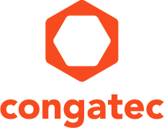
Reader enquiries: | Press contact:
congatec AG | SAMS Network
Christian Eder | Michael Hennen
Phone: +49-991-2700-0 | Phone: +49-2405-4526720
info@congatec.com  www.congatec.com | info@sams-network.com  www.sams-network.com

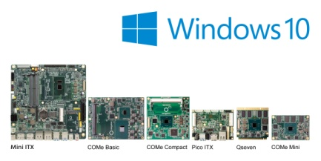
congatec’s boards now support Windows 10 IoT
Text and photograph available at: http://www.congatec.com/press

Press release

congatec now entirely supports the Windows 10 IoT editions

congatec’s latest OS implementation further simplifies development
of IoT-connected devices

Deggendorf, 31 January 2017 * * * congatec – a leading technology company for embedded computer modules, single board computers and embedded design and manufacturing services – has announced its comprehensive support of the IoT editions of Windows 10. These full versions of Windows 10 are characterized by their extended security functions and lockdown options for IoT-connected appliances. congatec has integrated these innovative features on all its current boards with Intel® Atom™, Celeron®, Pentium®, Core™ and Xeon® processors as well as AMD Embedded R and G Series processors. Customers benefit from an overall simplified development of IoT connected devices. Target markets include industrial automation and production, retail and outdoor advertising, the healthcare and transportation segments, plus a host of additional industries.

“Our customers who are using Windows 10 platforms want to develop innovative IoT applications and generate comprehensive business intelligence. They need highly unified, consistent and completely trustworthy OS support to cover all the embedded devices, tablets, smartphones and IT systems that are to be deployed. Supporting Windows 10 IoT is a very crucial milestone for us as part of an array of measures on our IoT roadmap which aims to simplify the integration and use of IoT connected embedded computer technology,“ Martin Danzer, Director Product Management at congatec, explains.

Main new features of congatec boards running Windows 10 IoT Enterprise
The Windows 10 IoT Enterprise as well as IoT Core editions, which congatec and Microsoft will support for at least 5 years for mainstream appliances and 5 additional years for customers with extended support, offer a range of security technologies such as Secure Boot, BitLocker, Device Guard and Credential Guard, to ensure that appliances are comprehensively protected for the entire operation time from power-on to power off. Whether just a particular app has to be launched or access to non-authorized USB peripherals has to be locked down, Windows 10 IoT provides the necessary functions for any specific device environment.

Additionally, Windows activation – which is otherwise obligatory – can be switched off to enable booting in locked network environments. Customers also benefit from the integrated interoperability for IoT-typical heterogeneous device environments, which apart from embedded appliances also integrate smartphones, PCs and laptops as well as edge, fog and cloud servers. That simplifies the development of universal apps and additionally the security and management of IoT applications. It also means that developers can completely focus on their tasks and core competences.

The new Windows 10 IoT Board Support Packages are now available in the download area of the corresponding congatec single board computers and modules: http://www.congatec.com/en/products.html

About congatec AG
Headquartered in Deggendorf, Germany, congatec AG is a leading supplier of industrial computer modules using the standard form factors COM Express, Qseven and SMARC as well as single board computers and EDM services. congatec’s products can be used in a variety of industries and applications, such as industrial automation, medical, entertainment, transportation, telecommunication, test & measurement and point-of-sale. Core knowledge and technical know-how includes unique extended BIOS features as well as comprehensive driver and board support packages. Following the design-in phase, customers are given support via extensive product lifecycle management. The company’s products are manufactured by specialist service providers in accordance with modern quality standards. Currently congatec has entities in USA, Taiwan, China, Japan and Australia as well as United Kingdom, France, and the Czech Republic. More information is available on our website at www.congatec.com or via Facebook, Twitter and YouTube.
* * *

Intel and Intel Atom, Celeron, Pentium, Core and Xeon are registered trademarks of Intel Corporation in the U.S. and other countries.

