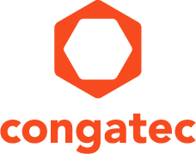
Reader enquiries: | Press contact:
congatec AG | SAMS Network
Christian Eder | Michael Hennen
Phone: +49-991-2700-0 | Phone: +49-2405-4526720
info@congatec.com  www.congatec.com | info@sams-network.com  www.sams-network.com

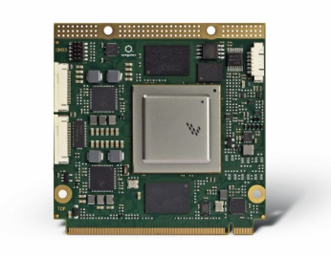

Text and photograph available at: http://www.congatec.com/press
Press release

congatec supports new NXP i.MX8 processors on Qseven and SMARC modules

congatec modules accelerate first-to-market strategies

Deggendorf, Germany, 22 November 2017 * * * congatec – a leading technology company for embedded computer modules, single board computers and embedded design and manufacturing services – announces support of the new 64-bit NXP i.MX8 processors for the Qseven and SMARC module standards. As a member of NXP’s Early Access Program, the new congatec modules will be available in time with the production launch of the new ARM Cortex A53 / A72 based processor family. This enables OEM customers to implement their first-to-market strategies efficiently, since they can start designing the carrier board for their applications now and will be able to leverage application-ready i.MX8 based congatec modules from day one of the launch date. No other design strategy promises faster time-to-market and higher design security. Customers gain important competitive advantages that they can use to capture crucial market share.

The new Qseven and SMARC modules with NXP i.MX8 real-time processors are of great interest for a wide range of industrial, stationary and in-vehicle applications, as the processors integrate up to four cores and high-performance graphics for up to four independent displays with low energy consumption. Since the modules are designed for the extended ambient temperature range from -40°C to +85°C, they can also be used in fleet systems for commercial vehicles or in infotainment applications in cabs, busses and trains as well as all the new electric and autonomous vehicles. The acceptance of these new platforms is accelerated by the widespread use of ARM technologies in the consumer electronics market, which further reinforces the dominance of ARM technology, especially in the (ultra-) low-power segment of embedded computer technologies.

“We see a strong increase in demand for ARM technologies in all low-power embedded segments, which we are in a perfect position to address with our Qseven and SMARC modules,” explains Martin Danzer, Director of Product Management at congatec. “Thanks to hardware support for the virtualization of the CPU and GPU cores as well as hardware-accelerated image and speech recognition, entirely new applications with innovative access control and user interface concepts are now conceivable, making the use of embedded ARM architecture even easier, more convenient and more versatile.”

“i.MX8 based Computer-on-Modules in the leading small form factor standards Qseven and SMARC enable developers to implement their projects with the shortest time to market and with very little NRE effort,” explains Steve Owen, Executive Vice President Global Sales at NXP. “With Computer-on-Modules, engineers can save minimum 50 percent and up to 90 percent time and NRE efforts compared to a full custom design. This modular approach is ideal for industrial batches as it significantly simplifies the use of ARM technologies. This opens new market segments for NXP’s i.MX technology where developers traditionally employed x86 technology. When solution providers such as congatec also offer embedded design and manufacturing services, they are an ideal starting point for full-custom designs with particularly high production volumes.”

congatec offers numerous important services around its modules, allowing design engineers to fully concentrate on the new features: The offer ranges from starter kits to EDM services and encompasses everything the developer’s heart desires. With congatec’s personal design-in support, OEMs also benefit from expert premium service from requirement engineering through to serial production. The first congatec modules and matching starter kits will be presented at Embedded World 2018 in Nuremberg. Customers can order starter kits with Qseven modules based on NXP i.MX6 processors today to enable them to switch to the new 64-bit platform the moment the new modules are launched. The first batches will be limited; interested OEM customers should register now for the exclusive congatec i.MX8 Early Access Program.

About congatec AG
Headquartered in Deggendorf, Germany, congatec AG is a leading supplier of industrial computer modules using the standard form factors COM Express, Qseven and SMARC as well as single board computers and EDM services. congatec’s products can be used in a variety of industries and applications, such as industrial automation, medical, entertainment, transportation, telecommunication, test & measurement and point-of-sale. Core knowledge and technical know-how includes unique extended BIOS features as well as comprehensive driver and board support packages. Following the design-in phase, customers are given support via extensive product lifecycle management. The company’s products are manufactured by specialist service providers in accordance with modern quality standards. Currently congatec has entities in USA, Taiwan, China, Japan and Australia as well as United Kingdom, France, and the Czech Republic. More information is available on our website at www.congatec.com or via Facebook, Twitter and YouTube.

* * *

