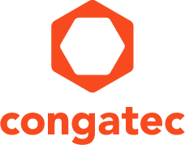
Reader enquiries: | Press contact:
congatec AG | SAMS Network
Christian Eder | Michael Hennen
Phone: +49-991-2700-0 | Phone: +49-2405-4526720
info@congatec.com  www.congatec.com | info@sams-network.com  www.sams-network.com

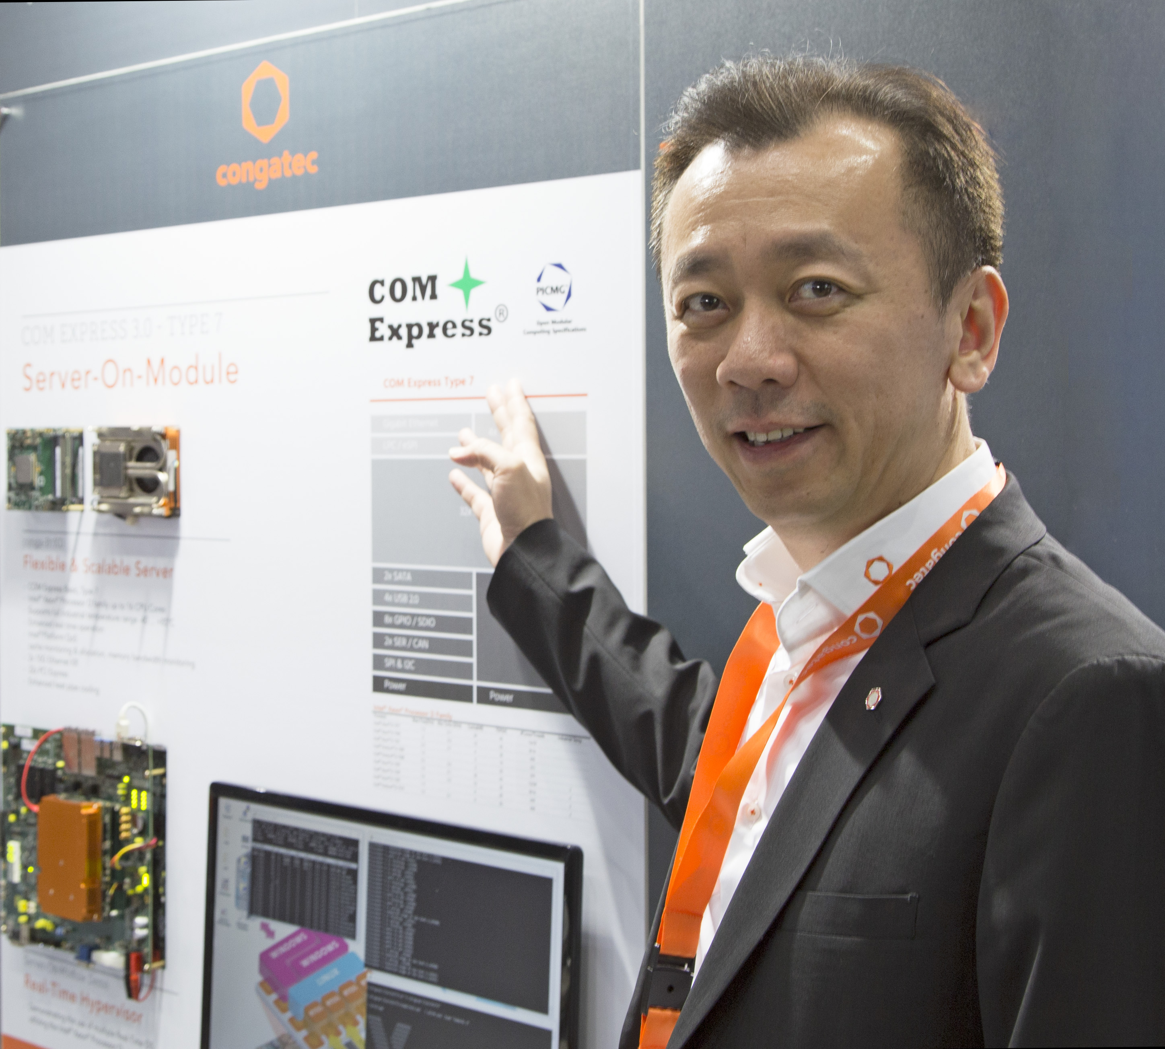
Bryan Lin, General Manager at congatec, leads of the global integration support team in APAC.
Text and photograph available at: http://www.congatec.com/press

Press release

COMPUTEX 2017: congatec announces the global availability of its personal integration support

Premium service for high-quality products are the key

Deggendorf, Germany, 23 May, 2017 * * * congatec – a leading technology company for embedded computer modules, single board computers and embedded design and manufacturing services – announces at COMPUTEX TAIPEI (Booth J1224) the global availability of its personal integration support for OEMs. Personal integration support is a premium service from congatec designed to simplify the use of embedded computing technologies. OEM customers around the globe benefit from a single contact point to get all their design-in questions answered. There is no need to wait in an impersonal hotline or speak to constantly changing contact persons. Instead, OEM customers around the globe benefit from a single contact point to get all their design-in questions answered. congatec’s premium service for OEM customers is simple, straightforward and comfortable for engineers, unique for the embedded computing market and globally available at no extra costs.

“Our global integration support engineers have a personal responsibility for customer requests and are trained to help customers’ engineers to significantly reduce cost and time efforts within their projects. By helping OEMs to overcome integration challenges we, in turn, help them improve their clients’ project performance while building a strong and trustful relationship and even a kind of joint team spirit. We feel that such premium services are a must have for companies working in the high-tech embedded industries, not only to enable fastest and most efficient time-to-market but also to create highest customer satisfaction,” explains Jason Carlson, CEO of congatec.

For China, Taiwan and further APAC countries, the congatec design center in Taipei – opened in 2015 – takes care of the personal integration support. The design centers for Europe are located in Deggendorf, Germany and Brno, Czech Republic. For the Americas, the design center is located in Boca Raton, Florida. Further personal integration service teams are located in the UK, France, Japan and Australia. At all these locations, customers receive premium support for the design-in of the latest new products and best-practice designs shown by congatec at the COMPUTEX trade show.

One highlight of the COMPUTEX showcase is the quick boot demo based on congatec’s Qseven conga-UMX6 computer-on-module with NXP’s (former Freescale) i.MX6 processors. i.MX6 processors enable a highly customizable quick boot of systems in less than a second from power off to full operation including running applications. This is vital for delivering the best user experience at maximum power savings. Typical use cases range from kiosk systems and video surveillance applications with motion detection to applications that need to be instantly available after an active impulse, such as in-car infotainment systems as well as all the manifold HMIs/GUIs of any machinery.

Also impressive is the new SMARC 2.0 computer-on-module demonstration on the basis of Intel® Atom™, Celeron® and Pentium® processors (codename Apollo Lake) where congatec presents the implementation of fully featured USB Type C connectivity with USB 3.1, power and graphics. With this universally applicable form of plug & play functionality, congatec greatly simplifies the use of embedded technology. Fully featured USB-C jacks are still rare and present a real breakthrough for standardizing the fragmented world of cable-based external interconnects. Such standardization is very beneficial for system engineers as well as system integrators, administrators and device users.
A highlight for the high-end embedded and edge sever sectors are the new COM Express Type 7 based server-on-modules offering server-grade performance and functionality with their Intel® Xeon® D processors, 2x 10 GbE and 32 PCIe lanes. The latter can be used for powerful intra system expansions such as GPGPUs and NVMe based ultra-fast storage devices as well as multi-module configurations on one single carrier board for high performance computing (HPC) designs. Application areas for the server-on-modules can be found in various scenarios from IT and carrier-grade server farms and cloudlets to edge, fog and Industry 4.0 servers.

congatec also showcases its broad portfolio of embedded boards and modules based on the latest Intel® Atom™, Celeron® and Pentium® processors (codename Apollo Lake) and Intel® Core™ processors (codename Kaby Lake) offering comprehensive off-the-shelf driver support for various industries and communication demands – including cash and payment protocol support for kiosk systems. This is one of the many distinctive benefits separating congatec’s offerings from competitive board level products that often don’t have such a broad footprint in the various smart device and machine building industries.

The new congatec Cloud API (Application Programming Interface), that is designed for IoT gateways and edge servers, rounds off the innovations displayed by the German provider of boards, modules and embedded design and manufacturing services. This API is made available to become the universal hub between local sensor networks and the IoT clouds. congatec’s new Cloud API for IoT Gateways communicates with local smart sensors, processes and converts the acquired data and executes automated actions based on a local rule engine, reducing traffic to the IoT cloud and enabling fast local actions. Secure bidirectional data exchange with any suitable clouds is achieved by using the TLS secured MQTT protocol. Clients can access this cloud via https in client or administrator mode. All these features make the new congatec Cloud API for IoT Gateways an ideal starting point for OEMs that wish to access smart sensor networks via IoT gateways and IoT edge servers on the basis of congatec’s comprehensive boards and module offerings ranging from COM Express, Qseven and SMARC modules to Pico-ITX and Mini-ITX motherboards plus various designs on IoT gateway level. Custom specific configurations of the congatec cloud API can be made available by congatec’s Embedded Design & Manufacturing Services (EDMS).

More information about congatec’s Qseven computer-on-modules with quick boot can be found at http://www.congatec.com/en/products/qseven/conga-umx6.html

More information on congatec’s new SMARC 2.0 conga-SA5 computer-on-modules can be found at http://www.congatec.com/products/smarc/conga-sa5.html

More information on congatec’s new COM Express Type 7 server-on-modules can be found at http://www.congatec.com/products/com-express-type7/conga-b7xd.html

About congatec AG
Headquartered in Deggendorf, Germany, congatec AG is a leading supplier of industrial computer modules using the standard form factors COM Express, Qseven and SMARC as well as single board computers and EDM services. congatec’s products can be used in a variety of industries and applications, such as industrial automation, medical, entertainment, transportation, telecommunication, test & measurement and point-of-sale. Core knowledge and technical know-how includes unique extended BIOS features as well as comprehensive driver and board support packages. Following the design-in phase, customers are given support via extensive product lifecycle management. The company’s products are manufactured by specialist service providers in accordance with modern quality standards. Currently congatec has entities in USA, Taiwan, China, Japan and Australia as well as United Kingdom, France, and the Czech Republic. More information is available on our website at www.congatec.com or via Facebook, Twitter and YouTube.

* * *

Intel and Intel Atom, Celeron, Pentium, Core and Xeon are registered trademarks of Intel Corporation in the U.S. and other countries.

