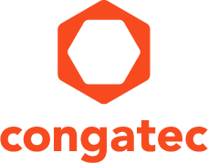
Reader enquiries: | Press contact:
congatec AG | SAMS Network
Christian Eder | Michael Hennen
Phone: +49-991-2700-0 | Phone: +49-2405-4526720
info@congatec.com  www.congatec.com | info@sams-network.com  www.sams-network.com

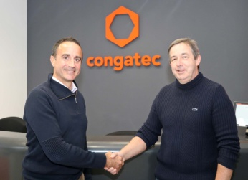
Sealing the new sales partnership: Luc Beugin, Sales Manager France at congatec, and Vincent Chevillot, Technical Director at APLUS Système Automation (ltr)
Text and photograph available at: http://www.congatec.com/presse

Press release
congatec now listed on the line card of APLUS Système Automation
congatec expands French sales partner network

Deggendorf, Germany, December 12, 2017 * * * congatec – a leading technology company for embedded computer modules, single board computers and embedded design and manufacturing services – has expanded its French sales partner network and is now listed on the line card of APLUS Système Automation. The company, which is one of France’s leading distributors of industrial computing technology, will sell the congatec product portfolio from its five locations in Paris, Lyon, Toulouse, Nantes and Lille. As a result of the distribution partnership, customers will benefit from even better local consultancy and project management expertise. The APLUS team has 50 employees and also supports OEM customers with personalized Embedded Design & Manufacturing Services.

“We are very pleased that our line card now includes the leading European Computer-on-Module vendor congatec,” explains Carlos Cabanita, CEO of APLUS Système Automation. “Computer-on-Module designs are significantly more efficient than full-custom designs, shaving off between 50% and 90% development time and NRE cost. These benefits can now be passed on in full to our customers.”

“Customers with unique system layout requirements need more individual support than customers using motherboards or slot single board computers where no application-specific carrier board is needed,” said Michael Klett, Manager Sales Partners EMEA, congatec. “So we are immensely pleased to be able to significantly strengthen our French sales and consulting footprint with APLUS Système Automation.”

APLUS Système Automation, which has been active in the market since 1988, is particularly strong in the industrial, embedded, security and defense industries as well as in the areas of digital media and point-of-sale solutions. The company supports its customers from component selection to finished product, and accompanies them from the development of initial design studies through production, technical documentation and certification to the installation and maintenance of the systems on site.

The new distribution partnership complements existing distribution partnerships and will effectively relieve congatec’s French sales offices, allowing the team around Luc Beugin in Paris and Stephane Mailleau in Toulouse to focus on acquiring and supporting large key accounts along with sales partner support.

About Aplus Systeme Automation
APlus Systeme Automation offers its customers a wide range of tailored solutions that take into account the specificities and challenges of your project. Established in 1988, APlus Systeme Automation is now one of the leaders in the French industrial IT sector. Our team of 50 people has extensive knowledge of multiple business applications in the areas of distribution, defence, security and industry at large. We are able to design, develop and market comprehensive solutions, adapted to the most diverse constraints. Our solutions are implemented in the areas of trade and industry, transport and logistics, telecommunications, electronic banking, food processing, defence, security and health. APlus Systeme Automation is a major player in the distribution of hardware, which we select from a panel of leading providers. Partners with major clients, we offer a full range of subsets for which we ensure the importation, marketing, customer service, and for which we manage all the support services. For more information please visit www.aplus-sa.com.

About congatec AG
Headquartered in Deggendorf, Germany, congatec AG is a leading supplier of industrial computer modules using the standard form factors COM Express, Qseven and SMARC as well as single board computers and EDM services. congatec’s products can be used in a variety of industries and applications, such as industrial automation, medical, entertainment, transportation, telecommunication, test & measurement and point-of-sale. Core knowledge and technical know-how includes unique extended BIOS features as well as comprehensive driver and board support packages. Following the design-in phase, customers are given support via extensive product lifecycle management. The company’s products are manufactured by specialist service providers in accordance with modern quality standards. Currently congatec has entities in USA, Taiwan, China, Japan and Australia as well as United Kingdom, France, and the Czech Republic. More information is available on our website at www.congatec.com or via Facebook, Twitter and YouTube.

* * *

