Reader enquiries: | Press contact:
congatec AG | SAMS Network
Christian Eder | Michael Hennen
Phone: +49-991-2700-0 | Phone: +49-2405-4526720
info@congatec.com  www.congatec.com | info@sams-network.com  www.sams-network.com

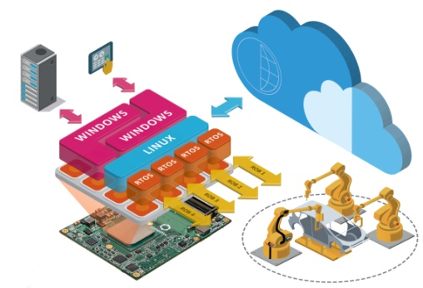
congatec’s virtualized edge sever platform offers real benefits
Text and photograph available at: http://www.congatec.com/presse
Press release
congatec virtualizes robust COM Express Type 7 Server-on-Module

congatec presents virtualized fog server installation

Deggendorf, Germany, October 26, 2017 * * * congatec – a leading technology company for embedded computer modules, single board computers and embedded design and manufacturing services – will be presenting its first robust, fanless, virtualized edge server platform for the extended temperature range at Embedded Conference Scandinavia (ECS) to be held in Stockholm from 7-9 November. The platform supports redundancy as well as real-time collaboration and consists of COM Express Type 7 modules with Intel® Atom™ processors (codename Denverton) and a real-time hypervisor from Real-Time Systems. The aim of this edge/fog server demo installation is to highlight the advantages of function virtualization and software defined services for IoT and Industry 4.0 connected rugged embedded server systems.

OEMs benefit from application-ready, virtualized, fanless embedded server platforms with up to 16 cores, giving them the ability to provide highly flexible real-time capable carrier-grade edge services as well as all kinds of shop floor based Industry 4.0 and M2M/IoT services. In addition, dedicated infrastructure components such as firewalls, load balancers and routing systems can be standardized with software-based solutions and consolidated on the fog servers themselves. All this helps OEMs increase the agility and cost-effectiveness of their communications infrastructures.

The installation in detail
The virtualized Server-on-Module platforms support redundant edge/fog server configurations that are connected via redundant 10 GbE interfaces, and can be used to install and manage any number of applications and services. There are also redundant core configurations for real-time support of machine controllers in which the individual cores and device resources can be prioritized or assigned exclusively. Thanks to the hardware independence of virtualized platforms, it is possible to develop multi-tenant nodes for faster implementation of heterogeneous machines, systems and sensor networks in Industry 4.0 environments, making these virtualized, real-time installations more agile, flexible and scalable. The installation is also suitable for high availability cloudlets and small cells at the edge of carrier infrastructures.

Application-ready Industry 4.0 and IoT platforms
The presented virtualized edge server platform is a flagship project of congatec’s extended services for Industry 4.0 and IoT ready Computer-on-Modules that come application-ready to use – including all required embedded software and hardware services. congatec provided design-in services, BIOS customization, driver and OS support including virtualization as well as all relevant hardware oriented services for this individually designed platform. These services include but are not limited to PCB checks of customers’ layouts, debugging, signal integrity simulation and testing; testing of EMC, power consumption and compliance; as well as thermal design and thermal adaptation.

About congatec AG
Headquartered in Deggendorf, Germany, congatec AG is a leading supplier of industrial computer modules using the standard form factors COM Express, Qseven and SMARC as well as single board computers and EDM services. congatec’s products can be used in a variety of industries and applications, such as industrial automation, medical, entertainment, transportation, telecommunication, test & measurement and point-of-sale. Core knowledge and technical know-how includes unique extended BIOS features as well as comprehensive driver and board support packages. Following the design-in phase, customers are given support via extensive product lifecycle management. The company’s products are manufactured by specialist service providers in accordance with modern quality standards. Currently congatec has entities in USA, Taiwan, China, Japan and Australia as well as United Kingdom, France, and the Czech Republic. More information is available on our website at www.congatec.com or via Facebook, Twitter and YouTube.

* * *

Intel and Intel Atom are registered trademarks of Intel Corporation in the U.S. and other countries.

