Reader enquiries: | Press contact:
congatec AG | SAMS Network
Christian Eder | Michael Hennen
Phone: +49-991-2700-0 | Phone: +49-2405-4526720
info@congatec.com  www.congatec.com | info@sams-network.com  www.sams-network.com

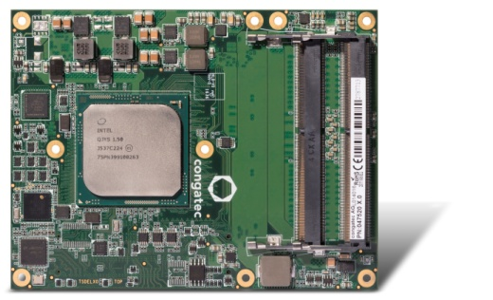
The conga-B7XD Server-on-Module brings server-grade functionality and performance to COM Express based computing designs
Text and photograph available at: http://www.congatec.com/press

Press release

congatec welcomes official release of the COM Express 3.0 specification

congatec’s Type 7 Server-on-Modules are now PICMG standard

Deggendorf, Germany, 13 April, 2017 * * * congatec – a leading technology company for embedded computer modules, single board computers and embedded design and manufacturing services, and editor of various Computer-on-Module specifications – welcomes the PICMG release of the COM Express 3.0 specification. The revision 3.0 of the specification formally integrates the new Type 7 pinout type which is the basis for congatec’s Server-on-Modules. The official release fires the starting shot for the race to a new generation of server designs based on standardized Server-on-Modules. These products enable the most cost efficient server designs and performance upgrades across all existing and upcoming generations of server class processors and sockets from any vendor. Modular server designs can be started instantly as modules, carrier boards, starter kits, design guides and circuit schematics are readily available.

“Server farms need constant upgrades to improve the performance and energy efficiency per rack. With the new Server-on-Modules, operators can execute these upgrades by simply exchanging standardized modules instead of complete and costly server boards or even rack systems,” explains Christian Eder, editor of the PICMG COM Express 3.0 specification and director marketing at congatec, the benefits of Server-on-Modules for cloudlets, edge and fog severs as well as any kind of data center servers tasked with delivering constantly improved rack performance at lower prices.

Server-on-Modules are also an excellent fit for all the various embedded and IoT server designs in harsh industrial environments where space is restricted and dedicated high-bandwidth interfaces are essential to connect the various controls in the industry 4.0 fields. Here, Server-on-Modules can massively improve design efficiency. This is of major significance for embedded design engineers as recent studies report that they are facing the challenge to constantly manage more projects within a given or even shorter time frame, leading to massive time pressure for executing each project. Server-on-Modules can deliver the vital design efficiency improvements by providing an application ready server core instead of only a hand full of individual components.

COM Express Type 7 Server-on-Modules, carrier boards and starter kits can be requested by customers for the evaluation of the new generation of modules. congatec’s recent Server-on-Module designs offer server-grade performance and functionality with their Intel® Xeon® D processors, 2x 10 GbE and 32 PCIe lanes.
The latter can be used for powerful intrasystem expansions such as GPGUs and NVMe based ultra-fast storage devices as well as multi-module configurations on one single carrier board for High Performance Computing designs.

More information on congatec’s new COM Express Type 7 Server-on-Modules can be found at http://www.congatec.com/products/com-express-type7/conga-b7xd.html

More information on congatec’s new carrier board for COM Express Type 7 modules can be found at http://www.congatec.com/products/accessories/conga-x7eval.html

The whitepaper about COM Express Type 7 is hosted at http://www.congatec.com/en/technologies/com-express/com-express-type-7/type-7-whitepaper-registration.html

A short video introduction about COM Express Type 7 is hosted at
https://www.youtube.com/watch?v=Gu1jycKQ0hY&list=PL7UXgPSAjr81KBNb9LnxyaQLmZmltQcID

About congatec AG
Headquartered in Deggendorf, Germany, congatec AG is a leading supplier of industrial computer modules using the standard form factors COM Express, Qseven and SMARC as well as single board computers and EDM services. congatec’s products can be used in a variety of industries and applications, such as industrial automation, medical, entertainment, transportation, telecommunication, test & measurement and point-of-sale. Core knowledge and technical know-how includes unique extended BIOS features as well as comprehensive driver and board support packages. Following the design-in phase, customers are given support via extensive product lifecycle management. The company’s products are manufactured by specialist service providers in accordance with modern quality standards. Currently congatec has entities in USA, Taiwan, China, Japan and Australia as well as United Kingdom, France, and the Czech Republic. More information is available on our website at www.congatec.com or via Facebook, Twitter and YouTube.

* * *

Intel and Intel Xeon are registered trademarks of Intel Corporation in the U.S. and other countries.

