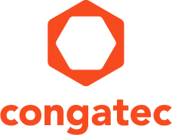
Reader enquiries: | Press contact:
congatec AG | SAMS Network
Christian Eder | Michael Hennen
Phone: +49-991-2700-0 | Phone: +49-2405-4526720
info@congatec.com  www.congatec.com | info@sams-network.com  www.sams-network.com

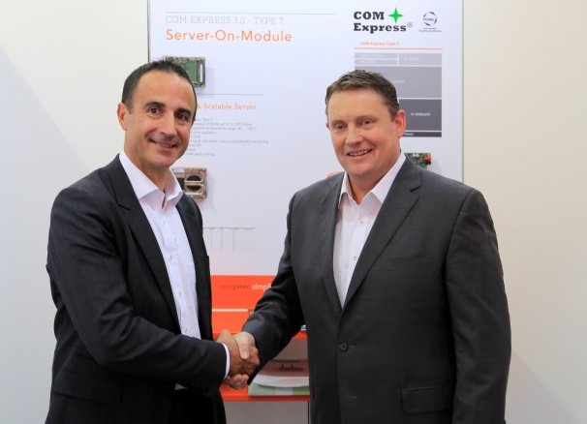
FRTL: Fred Barden welcomes congatec’s new Sales Manager for France Luc Beugin

Text and photograph available at: http://www.congatec.com/press

Press release

congatec establishes new subsidiary in France

congatec strives to become embedded go-to provider in France

Deggendorf, Germany / Paris, France, December 7, 2016 * * * congatec – a leading technology company for embedded computer modules, single board computers and embedded design and manufacturing services – has founded a new subsidiary in France with offices in Paris and Toulouse to strengthen its sales and support organization in France and the French speaking regions of Belgium and Switzerland. The aim of the new congatec France SAS is the intensified roll-out of the congatec brand as the natural go-to provider for embedded modules and SBCs in France, as congatec is in Germany today. Luc Beugin will manage our office in Paris. Stephane Mailleau will operate from Toulouse.

Jason Carlson, CEO of congatec, explains the company’s strategy for France: “We see a great pool of potential customers for our technologies in France and understand the importance of conducting business locally. This makes it imperative for us to strengthen our existing local engagement with congatec France to achieve faster growth. With our own subsidiary we will be able to better address the local needs – including support of our local distribution partners such as Tokhatec and the entire partner network that have accomplished a great job so far and continues to multiply our efforts. Our offices will be located in Paris and Toulouse, which is a perfect fit for our customers. We will service the entire range from start-ups to large multi-nationals across many industries including medical, industrial and robotics, infotainment, transportation and aerospace, as well as IoT and communications. congatec’s strength is our focus on partnering with our customers to help them best meet their objectives. With our new local team we will be able to meet these needs of our French customers even better and drive strong growth in France and the French speaking regions of Belgium and Switzerland.”

Fred Barden, Vice President Worldwide Sales, comments on the new sales team setup for France: “The sales process in the industrial and embedded computing industry is long and demanding and relies on trustful relationships and local support. I know that Luc and Stephane are excited to be further extending our reach by bringing our world class local sales and support structures now also to France.”

About congatec AG
Headquartered in Deggendorf, Germany, congatec AG is a leading supplier of industrial computer modules using the standard form factors COM Express, Qseven and SMARC as well as single board computers and EDM services. congatec’s products can be used in a variety of industries and applications, such as industrial automation, medical, entertainment, transportation, telecommunication, test & measurement and point-of-sale. Core knowledge and technical know-how includes unique extended BIOS features as well as comprehensive driver and board support packages. Following the design-in phase, customers are given support via extensive product lifecycle management. The company’s products are manufactured by specialist service providers in accordance with modern quality standards. Currently congatec has entities in Taiwan, Japan, China, USA, Australia, Czech Republic, United Kingdom and France. More information is available on our website at www.congatec.com or via Facebook, Twitter and YouTube.

* * *

