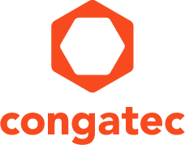
Reader enquiries: | Press contact:
congatec AG | SAMS Network
Christian Eder | Michael Hennen
Phone: +49-991-2700-0 | Phone: +49-2405-4526720
info@congatec.com  www.congatec.com | info@sams-network.com  www.sams-network.com

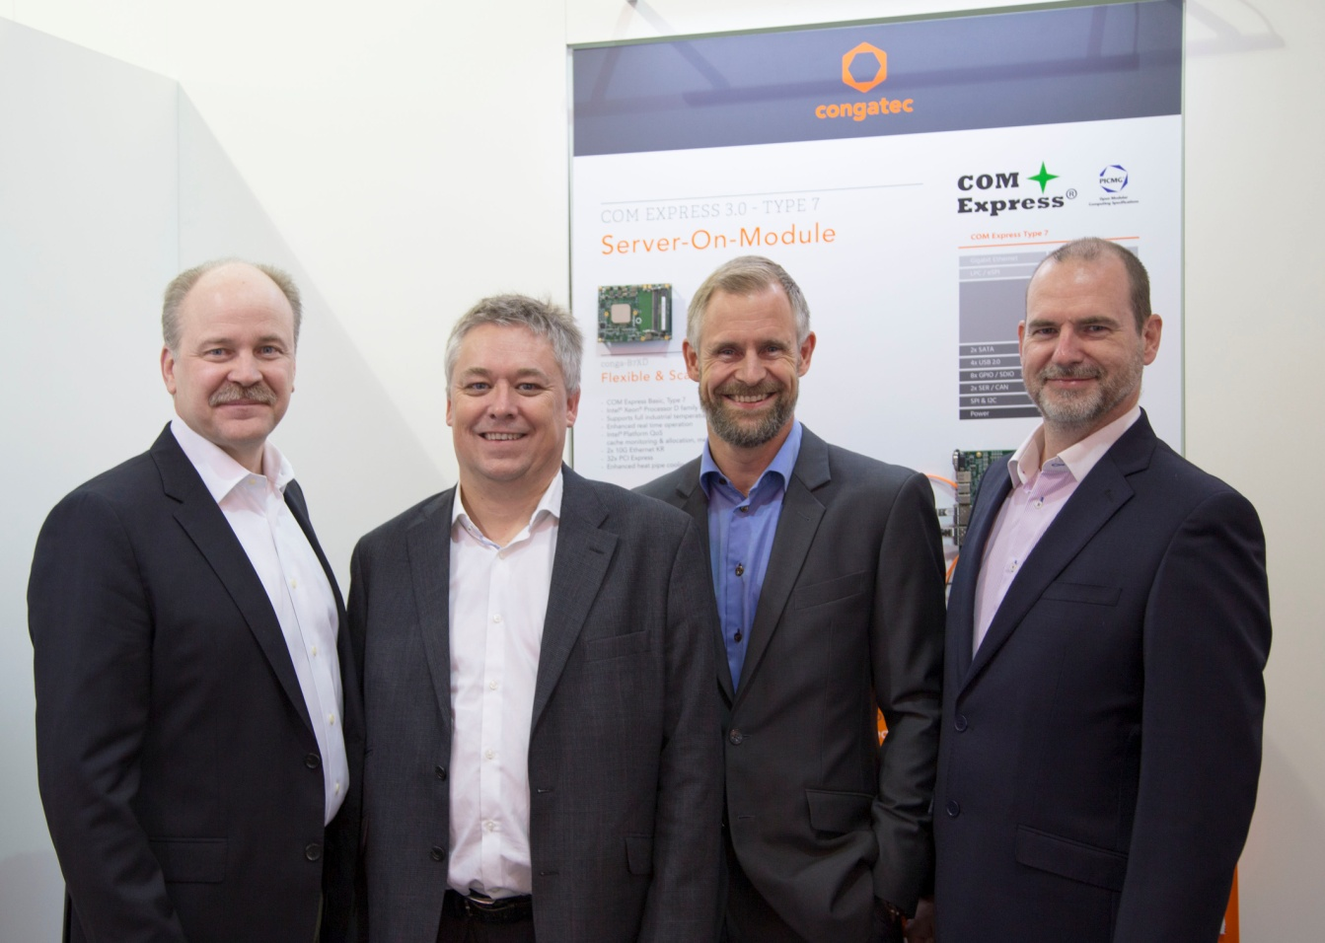
FLTR: Jason Carlson welcomes Martin Frederiksen, Jon Moseley and Anders Rasmussen.
Text and photograph available at: http://www.congatec.com/press

Press release

congatec strengthens its sales and support organization
in the UK and in Scandinavia

Martin C. Frederiksen joins congatec as Sales Director for Northern Europe

Deggendorf, Germany / London, UK, November 10, 2016 * * * congatec – a leading technology company for embedded computer modules, single board computers and embedded design and manufacturing services – appoints Martin C. Frederiksen as Sales Director for Northern Europe to strengthen its sales and support organization in the United Kingdom and in Scandinavia. Together with the appointment of Martin Frederiksen, the Northern European sales team has been extended further with the addition of Anders Rasmussen and Jon Moseley as Key Account Managers. Additionally, congatec has recently created a new, wholly owned London based subsidiary.

Jason Carlson, CEO of congatec, explains the company’s strategy for the UK and Scandinavia: “These regions are home to many great companies from start-ups to large multi-nationals across many industries including medical and industrial, IoT, communications, and transportation. congatec’s strength is our focus on partnering with our customers to help them best meet their objectives. Martin, Jon, and Anders are veterans of the embedded industry, and will leverage their experience to meet the needs of these customers and drive strong growth in these regions.

Fred Barden, Vice President Worldwide Sales, comments on the new sales team setup for the Nordics and the UK: “The sales process in the industrial and embedded computing industry is long and demanding and relies on trustful relationships. We will brand congatec as the natural go-to- provider of embedded modules and SBCs in Northern Europe, as congatec is in Germany today. The new sales team has long experience in generating sustained growth and I have full confidence that we will be able to open a lot of new opportunities to extend congatec’s reach in the UK and Nordics. I know Martin, Anders, and Jon are excited to be further extending our reach with their world class sales and support as part of the congatec team.”

About congatec AG
Headquartered in Deggendorf, Germany, congatec AG is a leading supplier of industrial computer modules using the standard form factors COM Express, Qseven and SMARC as well as single board computers and EDM services. congatec’s products can be used in a variety of industries and applications, such as industrial automation, medical, entertainment, transportation, telecommunication, test & measurement and point-of-sale. Core knowledge and technical know-how includes unique extended BIOS features as well as comprehensive driver and board support packages. Following the design-in phase, customers are given support via extensive product lifecycle management. The company’s products are manufactured by specialist service providers in accordance with modern quality standards. Currently congatec has entities in Taiwan, Japan, China, USA, Australia, United Kingdom and the Czech Republic. More information is available on our website at www.congatec.com or via Facebook, Twitter and YouTube.

* * *

