Reader enquiries: | Press contact:
congatec AG | SAMS Network
Christian Eder | Michael Hennen
Phone: +49-991-2700-0 | Phone: +49-2405-4526720
info@congatec.com  www.congatec.com | info@sams-network.com  www.sams-network.com

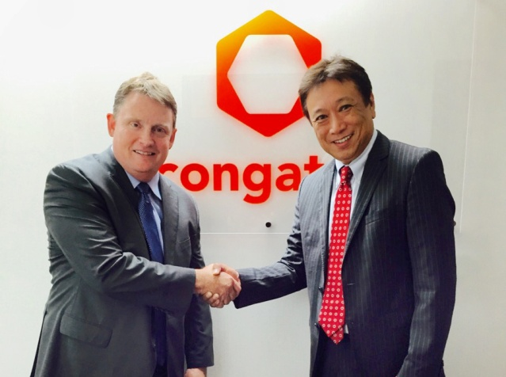
Fred Barden (left) welcomes Yasuyuki Tanaka as Country Manager and Sales Director for Japan
Text and photograph available at: http://www.congatec.com/press

Press release

congatec strengthens its Japanese sales and support organization

Yasuyuki Tanaka joins congatec as Country Manager Japan

Deggendorf, Germany / Tokyo, Japan, August 04, 2016 * * * congatec – a leading technology company for embedded computer modules, single board computers (SBCs) and embedded design and manufacturing (EDM) services – appoints Yasuyuki Tanaka as Country Manager and Sales Director for Japan. Tanaka is a key player of congatec’s global sales team and will be directly supported by congatec’s Vice President Worldwide Sales, Fred Barden. Barden was hired in 2015 to unite congatec’s global sales force in order to more effectively serve the top global players in the various markets for embedded and IoT computer technologies.

Jason Carlson, CEO of congatec, explains the company’s strategy for Japan: “Our goal is to massively extend our reach in this region. For the next five years, we plan high double-digit growth for each year. This makes it necessary to strengthen the local team with a new Country Manager and Sales Director for Japan who is capable to stimulate and manage strong growth. Yasuyuki Tanaka is an experienced sales leader and his deep insights into Japanese market structures will help our global sales force to accelerate growth by focusing on larger opportunities on a worldwide scale as well as innovative start-ups and professional markets in the IoT and communication sectors, in robotics, industrial and medical segments.”

Yasuyuki Tanaka, who studied executive business administration at University of Chicago, is a seasoned professional with 20 years of sales and sales management experience in the embedded, semiconductor and communication industry, 12 of which at the executive level. He collected his sales experience at leading embedded semiconductor vendors – including Nippon Avionics, Rockwell, Conexant Systems, Mindspeed Technologies and Macom – across various market segments making him a perfect candidate to maintain deep customer relationships with diverse OEM businesses. His track record ranges from broadcast, network processing, wireless systems, military and aerospace, medical, test & measurement, optical components and car navigation to mobile phones and other consumer electronics devices.

Yasuyuki Tanaka comments on his new role: "I am thrilled to join the prospering and highly motivated congatec team. It is an exciting time with many new opportunities. Many markets are converting and transforming towards new IoT driven business models, and Industry 4.0 changes the very way we manufacture. I am looking forward to working closely with our customers and sales partners to successfully navigate these transformations. This will definitely open a lot of opportunities to extend our activities in Japan, and we will empower our successful local sales and FAE team in Tokyo to jump at that chance with full engagement."

About congatec AG
Headquartered in Deggendorf, Germany, congatec AG is a leading supplier of industrial computer modules using the standard form factors COM Express, Qseven and SMARC as well as single board computers and EDM services. congatec’s products can be used in a variety of industries and applications, such as industrial automation, medical, entertainment, transportation, telecommunication, test & measurement and point-of-sale. Core knowledge and technical know-how includes unique extended BIOS features as well as comprehensive driver and board support packages. Following the design-in phase, customers are given support via extensive product lifecycle management. The company’s products are manufactured by specialist service providers in accordance with modern quality standards. Currently congatec has entities in Taiwan, Japan, China, USA, Australia and the Czech Republic. More information is available on our website at www.congatec.com or via Facebook, Twitter and YouTube.
* * *

