Reader Enquiries: | Press Contact:
congatec AG | PRismaPR  (UK, Scandinavia + Benelux) | PRismaPR
Christian Eder | Monika Cunnington | Bettina Lerchenmüller
Phone: +49-991-2700-0 | Phone: +44-20-8133 6148 | Phone: +49-8106-24 72 33
info@congatec.com  www.congatec.com | monika@prismapr.com  www.prismapr.com | info@prismapr.com  www.prismapr.com

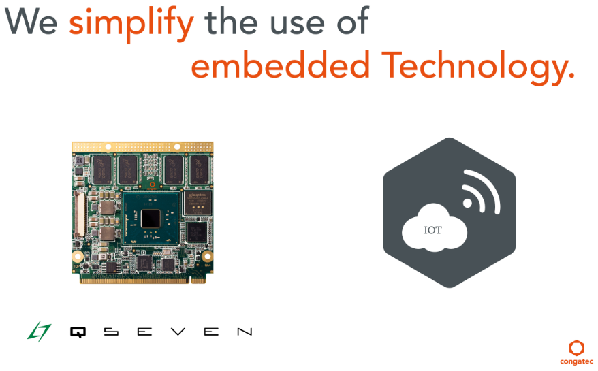
Text and photograph available: http://www.congatec.com/press

Visit congatec at COMPUTEX
Nangang Exhibition Hall, 1F Booth K1015
Press Release 10/2015
congatec to showcase a host of interesting innovations
at COMPUTEX 2015
COMPUTEX, Taipei, 2 June 2015 * * * congatec AG, a leading technology company for embedded computer modules, single board computers (SBCs) and embedded design and manufacturing (EDM) services, will present a wide range of innovations at this year's COMPUTEX show in Nangang Exhibition Hall, Stand K1015. The company’s two main product highlights at COMPUTEX 2015 are the Qseven computer module conga-QA4 and a Qseven IoT kit.
The conga-QA4 module features the new Intel Pentium® and Celeron® processors based on 14 nm technology and offers great energy savings as well as increased computing power. Based on congatec’s successful conga-QA3 Qseven Computer-on-Module (COM), the new IoT development kit makes it quick and easy to develop applications for the Internet of Things (IoT). The Qseven IoT kit contains everything needed for the rapid prototyping of embedded IoT applications. In addition to the Qseven COM with the latest Intel Atom processor, the starter kit includes a compact IoT carrier board, a 7" LVDS single touch display with LED backlight and an extensive set of accessories with Wind River Intelligent Device Platform XT on a USB stick.
congatec will also be showcasing its expanded range of single board computers (SBCs) featuring a new standard that is based on the Pico-ITX form factor and supporting the latest Intel Atom E3800 processors. Compact industrial computers, such as those based on the Pico-ITX form factor, can execute tasks reliably and also handle connectivity, from use in the field up to the management level.
Finally, congatec is presenting the COM Express computer module conga-TC97 and the Thin Mini-ITX SBC conga-IC97. Both products are based on the new 5th Generation Intel Core processor platform and provide highest industrial reliability up to Intel® Core™ i7-5650U processors. Developed on 14 nm technology, the processors of the 5th Generation Intel® Core™ platform offer excellent graphics and superior performance for Industry 4.0 connectivity.
As always, visitors to the congatec booth can enjoy a glass of orange juice, a cup of coffee, a cappuccino or a selection of other refreshments.
About congatec AG
Headquartered in Deggendorf, Germany congatec AG is a leading supplier of industrial computer modules using the standard form factors Qseven, COM Express, XTX and ETX, as well as single board computers and EDM services. congatec’s products can be used in a variety of industries and applications, such as industrial automation, medical technology, entertainment, transportation, telecommunication, test & measurement and point-of sale. Core knowledge and technical know-how includes unique extended BIOS features as well as comprehensive driver and board support packages. Following the design-in phase, customers are given support via extensive product lifecycle management. The company’s products are manufactured by specialist service providers in accordance with modern quality standards. Currently congatec has entities in Taiwan, Japan, China, USA, Australia and the Czech Republic. More information is available on our website at www.congatec.com or via Facebook, Twitter and YouTube.
* * *

Intel and Intel Core are trademarks of Intel Corporation in the U.S. and/or other countries.

