Reader Enquiries: | Press Contact:
congatec AG | PRismaPR  (UK, Scandinavia + Benelux) | PRismaPR
Christian Eder | Monika Cunnington | Bettina Lerchenmüller
Phone: +49-991-2700-0 | Phone: +44-20-8133 6148 | Phone: +49-8106-24 72 33
info@congatec.com  www.congatec.com | monika@prismapr.com  www.prismapr.com | info@prismapr.com  www.prismapr.com

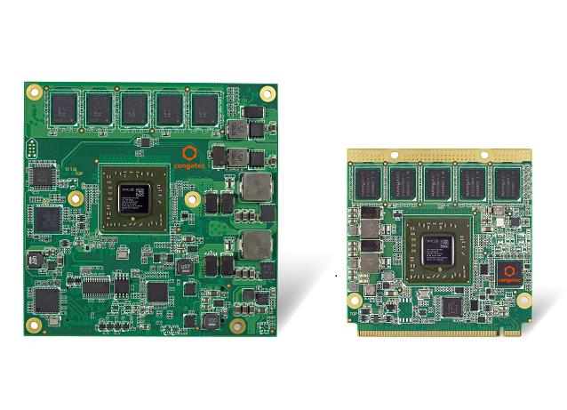
Visit us at embedded world
in Nuremberg, hall 1, stand 358

Text und Foto verfügbar: http://www.congatec.com/presse

Press release 06/2015
congatec extends availability of AMD processor-based
Computer-on-Modules
Qseven, COM Express, XTX and ETX Computer-on-Modules with AMD Embedded G-Series SoC now with 10 years long-term availability instead of 7 years
embedded world, Nuremberg, 24 February 2015 * * * congatec AG, a leading technology company for embedded computer modules, single board computers and EDM services, has extended the long-term availability of its AMD processor-based Computer-on-Modules from seven to ten years, securing the supply of Qseven, COM Express, XTX and ETX modules with AMD Embedded G-Series SoC in identical configuration for an additional three years. For the AMD Embedded G-Series SoC processors (formerly code named ‘Steppe Eagle’) this means an extension into the first quarter of 2024*. OEMs profit from the increased long-term availability by enhanced design and investment security as well as reduced non-recurring engineering costs (NRE) on a long-term basis. In addition, the careful selection of components assures a higher level of robustness which reinforces trouble-free operation in the field, thus reducing operating costs.
“OEMs want to use their designs as long as possible. This goal, however, is often marred by discontinuation announcements of components and processors making re-designs necessary. We want to break this cycle,” states Martin Danzer, Director Product Management at congatec AG. “What’s more, we are not ruling out that we might further extend the availability, as the new AMD G-Series SoCs perfectly match the performance class of powerful but low-power applications which are required in today’s industrial field and often deployed for decades. OEMs also want to redeem the high development costs, which they are currently investing in IoT and cloud connections of their machines and systems.”
“The trend of connecting all types of industrial machines and equipment as well as infrastructures and devices in transportation and energy to the internet means that many OEMs are working on completely new generations of control and monitoring devices,” said Kamal Khouri, director of marketing, AMD Embedded Solutions. “For these new designs we offer developers a new, reliable platform, which is available for longer than the usual seven years. For this reason we very much welcome congatec’s step to play a leading role in this area and support the extended long-term availability of the AMD Embedded G-Series processors with its designs.“
The availability of congatec’s new Computer-on-Modules with AMD Embedded G-Series processors has been set at 10 years. By incorporating congatec‘s new EDM services (Embedded Design & Manufacturing) on a project basis, even longer availabilities can be agreed on. The fanless modules are therefore an excellent match for cost-sensitive long-term deployments in control and automation technology, in digital gaming, in communication infrastructures as well as in graphics-intense appliances such as thin clients, digital signage or medical imaging devices.
All congatec modules are scalable from dual to quad core performance and offer up to 8 GByte ECC RAM. The integrated AMD Radeon™ graphics supports DirectX® 11.1 and OpenGL 4.2 for fast 2D and 3D image display, plus OpenCL 1.2 for executing program code through the graphics unit. All feature LVDS, DisplayPort 1.2 as well as DVI/HDMI 1.4a graphics interfaces for connecting two independently-run displays directly. Besides PCIe, both USB 3.0 and USB 2.0 ports are available for external peripherals. Storage medium can be connected via SATA 3 Gb/s ports and Gigabit Ethernet is provided for fast network connection.
*Details of the availability extensions of the AMD processors can be found on the AMD website at the respective ‘Longevity’ tab.
AMD Embedded G-Series Family of Processors:
http://www.amd.com/en-us/products/embedded/processors/g-series#

About congatec AG
congatec AG has its head office in Deggendorf, Germany and is a leading supplier of industrial computer modules using the standard form factors Qseven, COM Express, XTX and ETX, as well as single board computers and EDM services. congatec’s products can be used in a variety of industries and applications, such as industrial automation, medical technology, automotive supplies, aerospace and transportation. Core knowledge and technical know-how includes unique extended BIOS features as well as comprehensive driver and board support packages. Following the design-in phase, customers are given support via extensive product lifecycle management. The company’s products are manufactured by specialist service providers in accordance with modern quality standards. Currently congatec has 177 employees and entities in Taiwan, Japan, China, USA, Australia and the Czech Republic. More information is available on our website at www.congatec.com or via Facebook, Twitter and YouTube.
* * *

