

|  |  |  |  |
| --- | --- | --- | --- |
| **Reader Enquiries:** | **Press Contact:** |  | |
| **congatec AG** | **PRismaPR  (UK, Scandinavia + Benelux)** | **PRismaPR** |
| Christian Eder | Monika Cunnington | Bettina Lerchenmüller |
| Phone: +49-991-2700-0 | Phone: +44-20-8133 6148 | Phone: +49-8106-24 72 33 |
| [info@congatec.com](mailto:info@congatec.com)  [www.congatec.com](http://www.congatec.com/) | [monika@prismapr.com](mailto:monika@prismapr.com)  [www.prismapr.com](http://www.prismapr.com/) | [info@prismapr.com](mailto:info@prismapr.com)  [www.prismapr.com](http://www.prismapr.com/) |

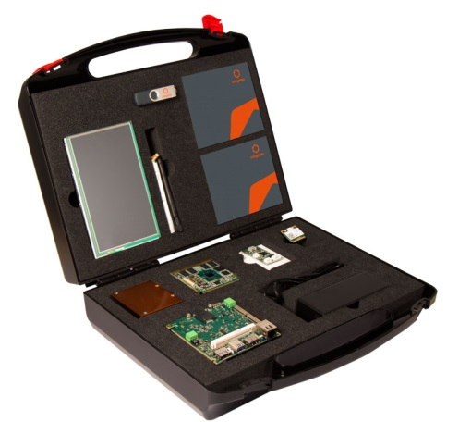

***Visit congatec at embedded world  
in Nuremberg, hall 1, booth 358***

*Photo available:* [www.congatec.com](http://www.congatec.com/)

Press Release 05/2015

**Qseven IoT kit from congatec simplifies   
IoT application development**

**embedded world, Nuremberg, 24 February 2015 * * \*** congatec AG, a leading technology company for embedded computer modules, single board computers and EDM services, has released a Qseven IoT kit that makes it quick and easy to develop applications for the Internet of Things (IoT). The kit provides a complete starter set for the rapid prototyping of embedded IoT applications. The Qseven IoT kit contains a Qseven Computer-on-Module (COM) based on the latest Intel Atom processor technology, a compact IoT carrier board, a 7" LVDS single touch display with LED backlight, and an extensive set of accessories including AC power supply and 802.11 WLAN antenna with IoT Wind River Linux image on a USB stick. With this kit, developing an IoT demo system takes a matter of minutes.

The kit comes with congatec’s successful conga-QA3 Qseven COM based on the new Intel® Atom™ E3827 processor (XM cache, 1.6GHz, XW TDP). A space-saving single-chip processor and low power consumption make this an ideal solution for fanless designs in applications that require enhanced IoT connectivity. These include, for example, M2M and motion control applications for industry 4.0, gateways, or system and control monitoring in smart home automation.

The Qseven module comes with 2 GB of DDR3L memory and up to 16 GB eMMC 4.5 for mass storage. Thanks to native USB 3.0 support, the module achieves fast data rates with low power consumption. A total of six USB 2.0 ports are provided, one of which supports USB 3.0 SuperSpeed. Three PCI Express 2.0 lanes and two SATA interfaces operating at up to 6 Gb/s enable fast and flexible system extensions. The Intel® Gigabit Ethernet Controller i210 ensures outstanding software compatibility. An I2C bus, an LPC bus for easy integration of legacy I/O interfaces, and Intel High Definition Audio complete the feature set.

The combination of a 70mm x 70mm Qseven module with a processor from the Intel® Atom™ E3800 family and an IoT baseboard results in an ultra-compact hardware kit. Use of the new Intel Atom processors further ensures that the embedded PC features extremely low power consumption while providing the highest performance. The integrated Intel® Gen 7 HD graphics sets new standards for graphics-intensive applications in the low-power segment. The compact baseboard design and the many interface options and functions enable fast and cost-efficient implementation of powerful, yet passively cooled embedded systems, such as box PCs and customized solutions.

In combination with the validated package of “Intel Gateway Solutions for IoT”, the conga‑QA3 provides a pre-integrated and open platform to bring secure IoT solutions quickly to market.

**About congatec AG**congatec AG has its head office in Deggendorf, Germany and is a leading supplier of industrial computer modules using the standard form factors Qseven, COM Express, XTX and ETX, as well as single board computers and EDM services. congatec’s products can be used in a variety of industries and applications, such as industrial automation, medical technology, automotive supplies, aerospace and transportation. Core knowledge and technical know-how includes unique extended BIOS features as well as comprehensive driver and board support packages. Following the design-in phase, customers are given support via extensive product lifecycle management. The company’s products are manufactured by specialist service providers in accordance with modern quality standards. Currently congatec has 177 employees and entities in Taiwan, Japan, China, USA, Australia and the Czech Republic. More information is available on our website at [www.congatec.com](http://www.congatec.com) or via [Facebook](http://www.facebook.com/Congatec), [Twitter](https://mobile.twitter.com/congatecAG) and [YouTube](http://www.youtube.com/congatecAE).

* * *

*Intel and Intel Core are trademarks of Intel Corporation in the U.S. and/or other countries.*