Reader Enquiries: | Press Contact:
congatec AG | PRismaPR  (UK, Scandinavia + Benelux) | PRismaPR
Christian Eder | Monika Cunnington | Bettina Lerchenmüller
Phone: +49-991-2700-0 | Phone: +44-20-8133 6148 | Phone: +49-8106-24 72 33
info@congatec.com  www.congatec.com | monika@prismapr.com  www.prismapr.com | info@prismapr.com  www.prismapr.com

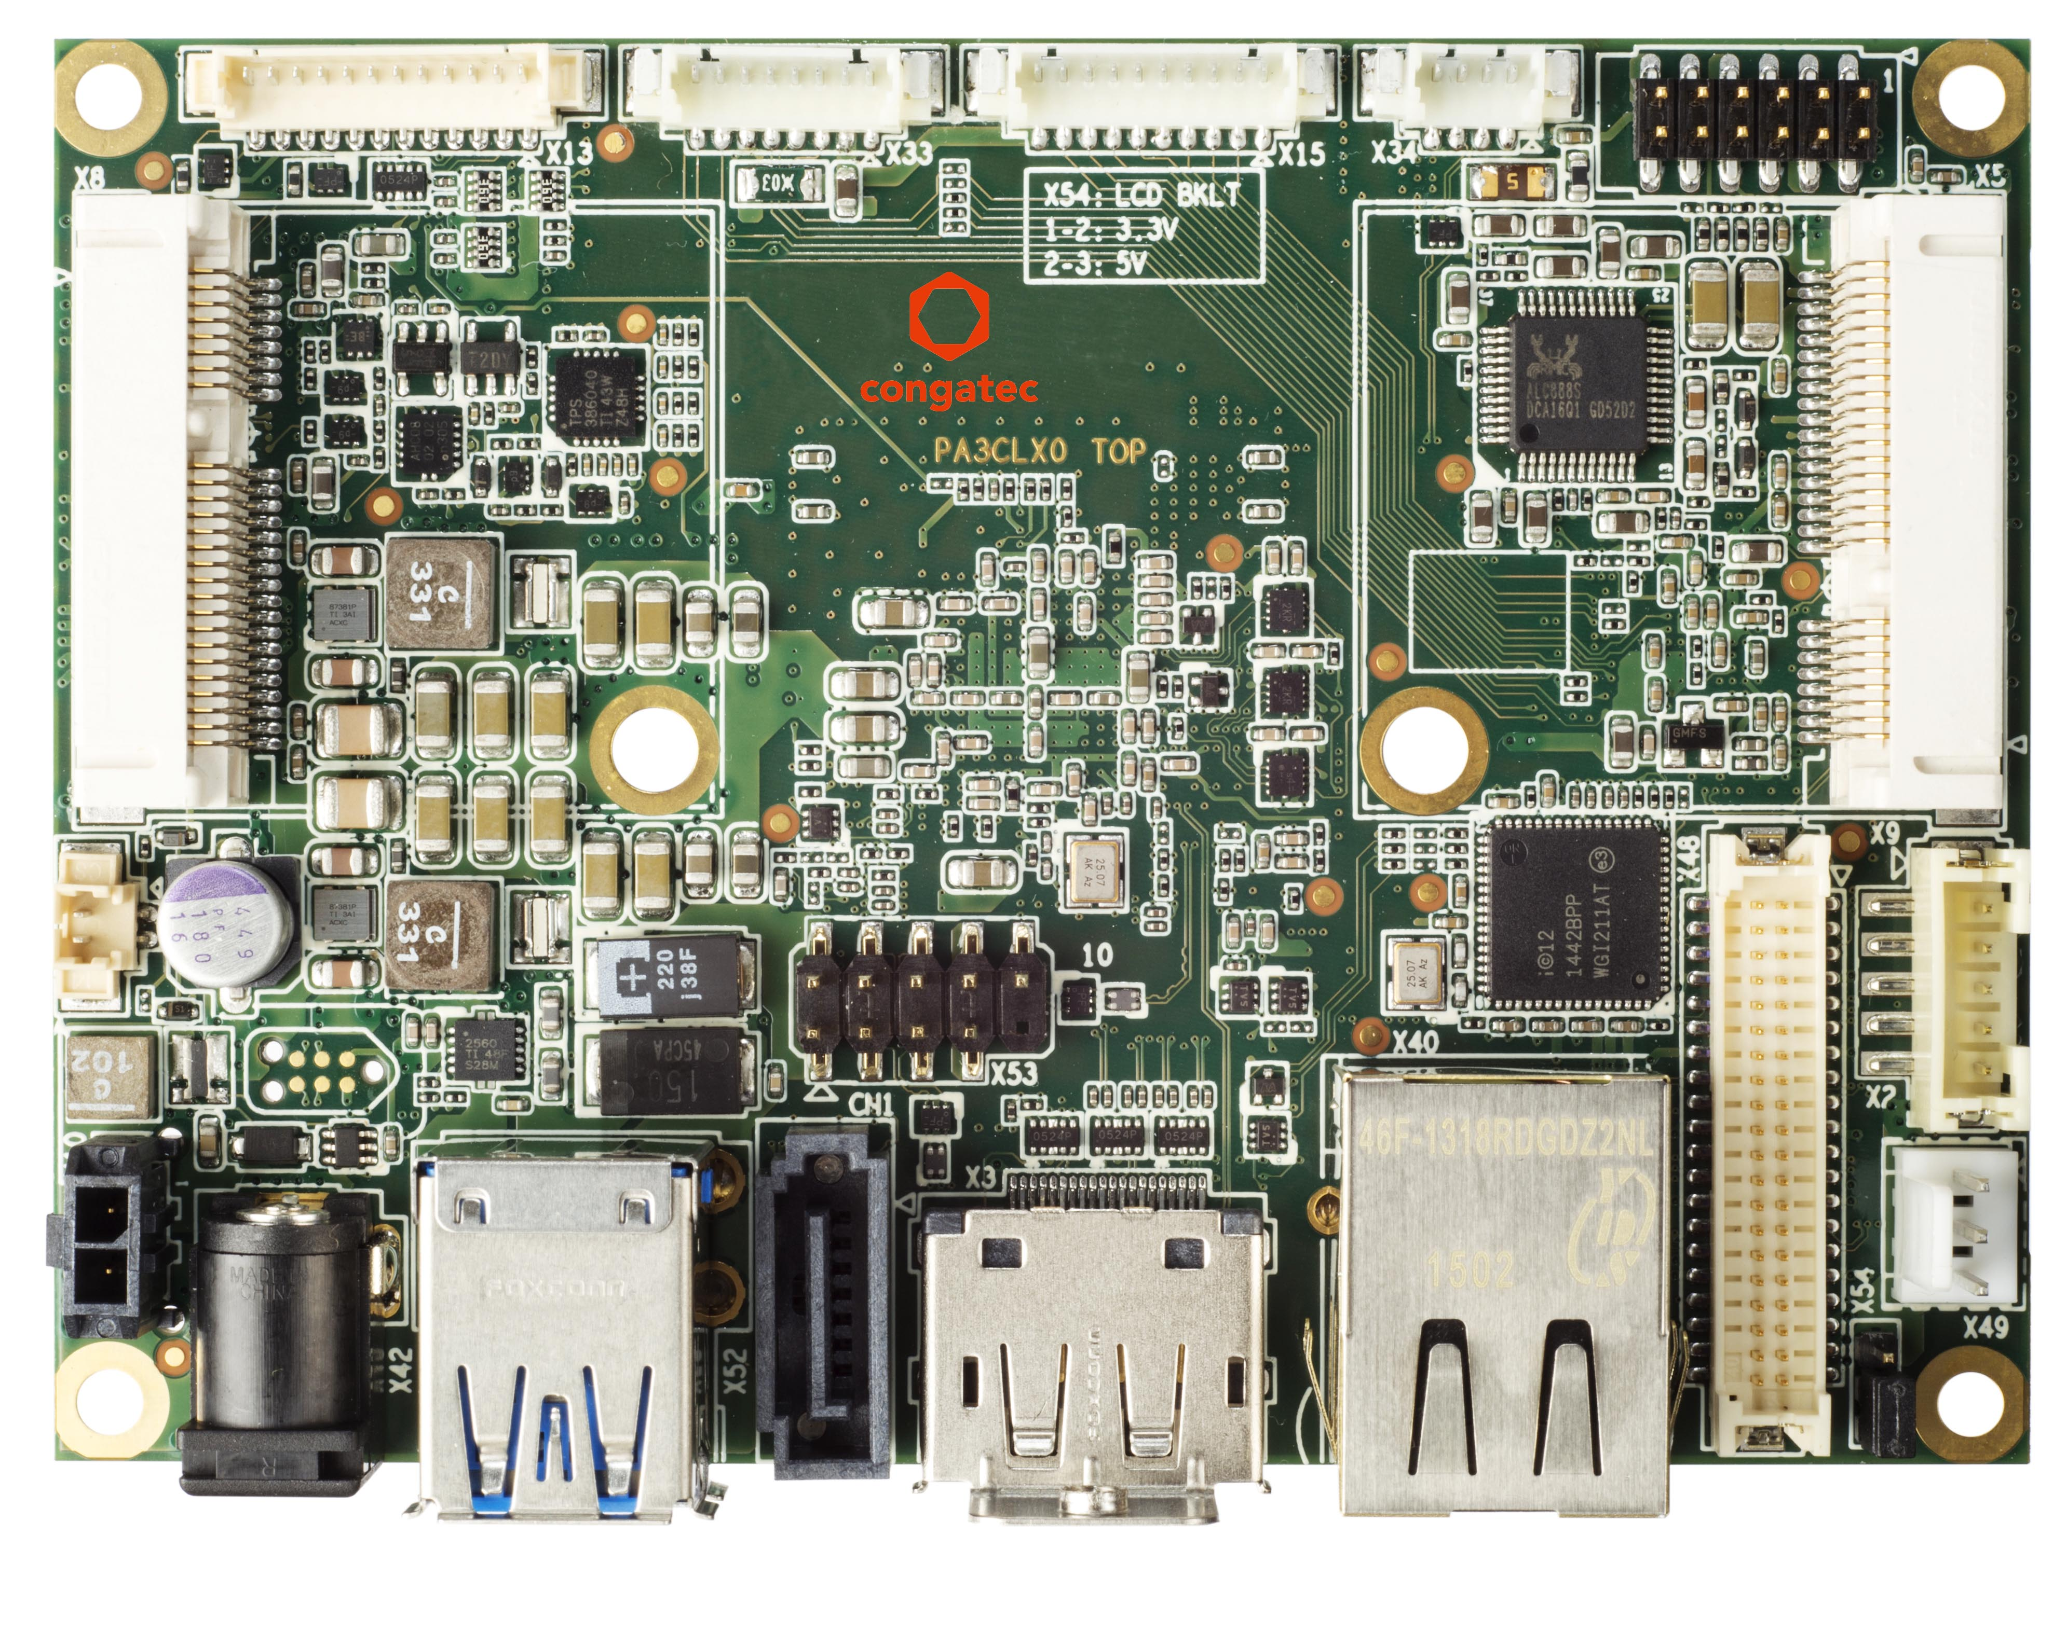
Visit congatec at embedded world
in Nuremberg, hall 1, booth 358

Photo available: www.congatec.com

Press Release 04/2015
Compact and complete: congatec’s Pico-ITX single board computer
Industrial single board computer based on Intel® Atom™ E3800 processor series
(code named Bay Trail)

embedded world, Nuremberg, 24 February 2015 * * * congatec AG, a leading technology company for embedded computer modules, single board computers (SBCs) and EDM services, announces a new Pico-ITX SBC based on the Intel® Atom™ E3800 processor series.
Industry 4.0 is ringing in new infrastructure requirements. What is needed are compact and reliable industrial computers, such as those based on the Pico-ITX form factor, that cannot only be trusted to perform tasks reliably, but that can also provide connectivity from use in the field up to the management level. The compact design with a footprint of 70x102mm makes the SBC highly versatile. Real-time capability and support for multiple operating systems allow use in demanding industrial applications such as mechanical engineering or automation and control systems. The Intel® Atom™ E3800 processors are also suitable for use in the extended industrial temperature range. Thanks to their low power consumption with just 5 to 10 Watt TDP, the single-chip Bay Trail solutions are ideal for passively cooled and enclosed systems that can be used in harsh environments. When high-performance graphics with extensive 3-D capabilities are not required, and when two independent displays with full HD resolution are sufficient, the Pico-ITX SBC from congatec proves to be reliable and cost effective. Typical applications include control of large machines with decentralized, distributed intelligence, robotics, all types of intelligent measurement and analysis devices, and high-performance IoT computers with low power consumption.
With the conga-PA3, congatec has released a powerful, low-power SBC with embedded qualities. The widespread and highly compact Pico-ITX form factor enables high volumes at low prices. Customers receive a robust SBC with a guaranteed availability of at least 7 years that is also suitable for 24/7 operation in harsh environments. Optional versions for the extended industrial temperature range of -40° to +85° C are also available.
Currently, there are two configurations: A dual-core Intel Atom E3826 and a quad-core Intel Atom E3845. Both processors are from Intel’s 64 bit Bay Trail family and are full System-on-Chips (SoCs) characterized by high efficiency and an excellent price/performance ratio. Additional CPUs can easily be implemented as tailored products when minimum production quantity levels are met.
The integrated Intel Gen7 HD graphics supports two independent displays in Full HD resolution (LVDS 2x24bit via an internal connector and DP++; and HDMI1.4 via a connector on the I/O panel). The hardware supports or directly accelerates DirectX 11.1, OpenGL 3.2 and OpenCL 1.2. The RAM memory is soldered to the board. Depending on the processor, a total of up to 4GB DDR3L-1666 are available. The I/O panel further provides two USB2.0 ports, an RJ-45 connector for 10/100/1000 GB Ethernet, plus a 12V DC power supply.
Also integrated are an additional USB 2.0 port, a USB 3.0 SuperSpeed port, a connector for backlight and LVDS, fan control, HDA audio, two serial ports (RS232, RS232/485/422), a SATA connection, a half-size slot for shared mSATA/miniPCIe, plus another half-size miniPCIe slot.
Various interfaces including ACPI 5.0, I2C bus and LPC bus allow easy integration of legacy I/O interfaces via the feature connector. Real-time clock (RTC) and Intel High Definition Audio complete the feature set.

The following processor options are available:
Processor | Cores | Cache [MB] | Clock [GHz] | TDP [W]
Intel® Atom® E3845 | 4 | 2 | 1.91 | 10.0
Intel® Atom® E3826 | 2 | 1 | 1.46 | 7.0

About congatec AG
congatec AG has its head office in Deggendorf, Germany and is a leading supplier of industrial computer modules using the standard form factors Qseven, COM Express, XTX and ETX, as well as single board computers and EDM services. congatec’s products can be used in a variety of industries and applications, such as industrial automation, medical technology, automotive supplies, aerospace and transportation. Core knowledge and technical know-how includes unique extended BIOS features as well as comprehensive driver and board support packages. Following the design-in phase, customers are given support via extensive product lifecycle management. The company’s products are manufactured by specialist service providers in accordance with modern quality standards. Currently congatec has 177 employees and entities in Taiwan, Japan, China, USA, Australia and the Czech Republic. More information is available on our website at www.congatec.com or via Facebook, Twitter and YouTube.
* * *

Intel and Intel Core are trademarks of Intel Corporation in the U.S. and/or other countries.

