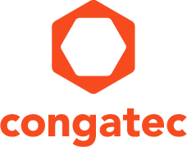

Reader Enquiries: | Press Contact:
congatec AG | PRismaPR  (UK, Scandinavia + Benelux) | PRismaPR
Christian Eder | Monika Cunnington | Bettina Lerchenmüller
Phone: +49-991-2700-0 | Phone: +44-20-8133 6148 | Phone: +49-8106-24 72 33
info@congatec.com  www.congatec.com | monika@prismapr.com  www.prismapr.com | info@prismapr.com  www.prismapr.com

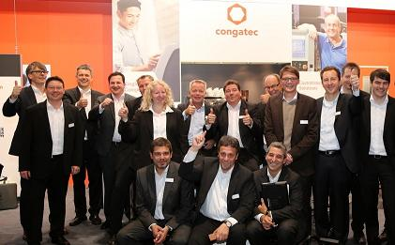
Photo available: www.congatec.com

Visit congatec at embedded world
in Nuremberg, Hall 1, Booth 358
Press Release 02/2015
congatec to showcase many interesting innovations at
embedded world 2015
At this year's Embedded World, congatec will present a wide range of innovations in Hall 1, Stand 358. Next to the conga-TC97 COM Express board, the company will also show the new Mini-ITX board conga-IC97
Deggendorf, Germany, 9 February 2015 * * * The two main product highlights at Embedded World 2015 are the COM Express computer module conga-TC97 and the Thin Mini-ITX Single Board Computer conga-IC97. Both products are based on the new 5th Generation Intel Core processor platform and provide highest industrial reliability up to Intel® Core™ i7-5650U processors.
Developed on 14 nm technology, the processors of the 5th Generation Intel® Core™ platform offer excellent graphics and superior performance for Industry 4.0 connectivity.
congatec has also expanded its range of single board computers with a new standard that is based on the Pico-ITX form factor and supports the latest Intel Atom E3800 processors. The company sees great demand for compact industrial computers, such as those based on the Pico-ITX form factor, that can execute tasks reliably and also handle connectivity, from use in the field up to the management level.
Last but not least, congatec is presenting a new IoT development kit that enables entrance to the Internet of Things within minutes. The Qseven IoT Kit contains everything needed for the rapid prototyping of embedded IoT applications. In addition to the Qseven Computer-on-Module with the latest Intel Atom processor, the starter kit includes a compact IoT carrier board, a 7" LVDS single touch display with LED backlight and an extensive set of accessories with Wind River Intelligent Device Platform XT on a USB stick.
As always, visitors to the congatec booth can revitalize their energy with a glass of freshly squeezed orange juice, a cup of coffee, a cappuccino or a selection of other refreshments.

About congatec AG
congatec AG has its head office in Deggendorf, Germany and is a leading supplier of industrial computer modules using the standard form factors Qseven, COM Express, XTX and ETX, as well as single board computers and EDM services. congatec’s products can be used in a variety of industries and applications, such as industrial automation, medical technology, automotive supplies, aerospace and transportation. Core knowledge and technical know-how includes unique extended BIOS features as well as comprehensive driver and board support packages. Following the design-in phase, customers are given support via extensive product lifecycle management. The company’s products are manufactured by specialist service providers in accordance with modern quality standards. Currently congatec has 177 employees and entities in Taiwan, Japan, China, USA, Australia and the Czech Republic. More information is available on our website at www.congatec.com or via Facebook, Twitter and YouTube.
* * *

Intel and Intel Core are trademarks of Intel Corporation in the U.S. and/or other countries.

