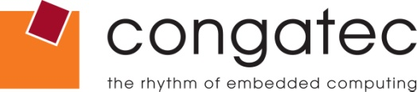

 | Reader Enquiries: | Press Contact:
congatec AG |  | PRismaPR  (UK, Scandinavia + Benelux) | PRismaPR
Christian Eder |  | Monika Cunnington | Bettina Lerchenmüller
Phone: +49-991-2700-0 |  | Phone: +44-20-8133 6148 | Phone: +49-8106-24 72 33
info@congatec.com  www.congatec.com |  | monika@prismapr.com  www.prismapr.com | info@prismapr.com  www.prismapr.com

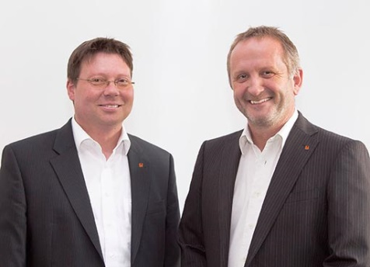
Photo available: www.congatec.com

Press Release 12/2014
congatec AG appoints Matthias Klein to the Executive Board
Deggendorf, Germany, 25 August 2014 * * * congatec AG announces the appointment of Matthias Klein as Chief Operating Officer (COO) and member of the Executive Board.
Matthias Klein, who has worked as VP of Operations at congatec since May 2013, joins CEO Gerhard Edi on the Board with immediate effect. While Gerhard Edi focusses on matters of technology and finance, Matthias Klein concentrates on operations and sales.
Prior to joining congatec, Matthias Klein worked for over 16 years at Zollner Elektronik AG, Europe's largest EMS provider with its headquarters in Germany, where he gained experience in the production of advanced electronics. In his most recent position at Zollner as VP of Operations, he had technical and commercial responsibility for four production sites in Germany, Eastern Europe and Asia. Besides customer satisfaction, his focal points included global procurement and supply chain management.
In his new role as a member of the Executive Board, Matthias Klein will drive the continued expansion of congatec's international business. "By establishing additional international EMS services and optimizing production in our target regions, we will soon be in a position to offer our customers even more flexibility. In this newly created position, I can use my experience and ideas better and I look forward to helping congatec speed its success," says Matthias Klein.
"The appointment of Matthias Klein to the Board reflects our continued growth. Together, we will drive the strategic expansion of our product portfolio forward, embracing new technologies such as the Internet of Things and Industry 4.0. With the help of our 170 employees, we will continue to perpetuate the congatec success story into the future," comments congatec CEO Gerhard Edi.

About congatec AG
congatec AG has its head office in Deggendorf, Germany and is a leading supplier of industrial computer modules using the standard form factors Qseven, COM Express, XTX and ETX, as well as Single Board Computers (SBC) and ODM services. congatec’s products can be used in a variety of industries and applications, such as industrial automation, medical technology, automotive supplies, aerospace and transportation. Core knowledge and technical know-how includes unique extended BIOS features as well as comprehensive driver and board support packages. Following the design-in phase, customers are given support via extensive product lifecycle management. The company’s products are manufactured by specialist service providers in accordance with modern quality standards. Currently congatec has 170 employees and entities in Taiwan, Japan, USA, Australia and the Czech Republic. More information is available on our website at www.congatec.com or via Facebook, Twitter and YouTube.

* * *

