Press release

congatec introduces 3.5-inch application carrier board for COM-HPC Mini modules

The faster, more sustainable route to dedicated high-end 3.5-inch systems

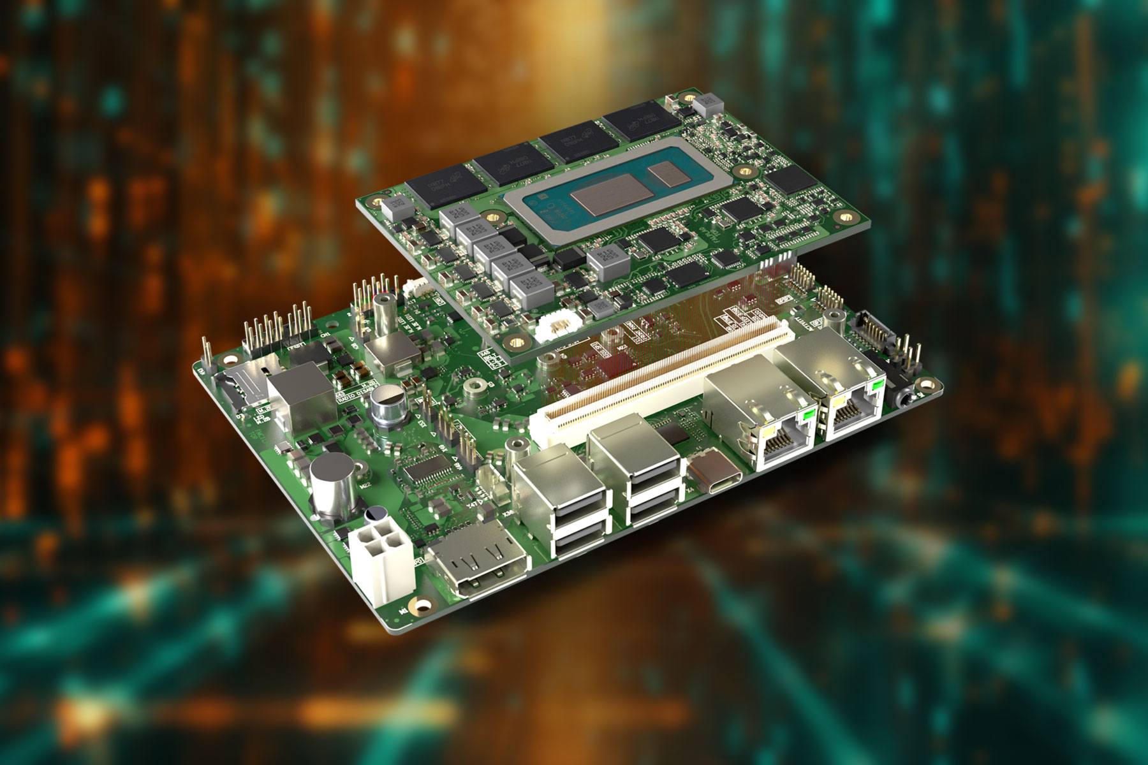

Deggendorf/Nuremberg, Germany, April 9th, 2024 * * * congatec – a leading provider of embedded and edge computing technology – presents the first board-level product in line with its recently introduced aReady. strategy. Application-ready for immediate deployment in industrial use cases, the new 3.5-inch conga-HPC/3.5-Mini carrier board is designed for space-constrained rugged high-performance IIoT applications that are based on COM-HPC Mini modules with extended temperature support from -40°C to + 85°C. When used in combination with the conga-aCOM/mRLP COM-HPC Mini module in aReady.COM version, the hypervisor and operating system configuration come pre-installed. A software expansion package for secure IIoT connection is on the roadmap. Developers can boot product bundles and install their applications immediately. As this minimizes the complexity of integration below the application layer and for the diverse IIoT functionalities of embedded and edge computing systems, the solution is also ideal for system integrators.

There are two purchasing options for this new commercial-off-the-shelf (COTS) carrier board. As a pure application carrier board with the conga-HPC/mRLP COM-HPC Mini module, it is an ideal platform for series products starting from small quantities. For application-specific designs, the complete aReady. bundle offers high convenience and design security. For instance, possible configurations can include a pre-installed ctrlX OS from Bosch Rexroth and virtual machines for tasks such as real-time control, HMI, AI, IIoT data exchange, firewall and maintenance/management functions. Both purchasing options are suitable for OEMs looking to develop sustainable system designs based on off-the-shelf components. Modular COTS configurations are primarily aimed at OEMs, system integrators and VARs of smaller industrial product series and families. What makes the solution sustainable is the option to replace only the module when performance and functionality requirements change, instead of the entire embedded hardware.

Heralding an application-specific modular embedded computing platform in a 3.5-inch format, both options offer an excellent technological foundation for rapid prototyping and price/performance balancing through processor selection. Customer-specific carrier board variants enable OEMs to realize dedicated designs with minimal development effort. This reduces costs, shortens time-to-market, and secures long-term investments in specific carrier board designs as upgrades are possible by swapping modules across processor generations and manufacturers. Larger production runs can also be realized cost-efficiently by merging the COM and carrier board.

“Minimizing the integration effort to the greatest extent possible provides immense added value for our customers. From our core Computer-on-Module business perspective, both the COTS carrier boards and the aReady. strategy with pre-installed hypervisor, operating system, and IIoT software configurations are therefore important add-on benefits that we can now offer customers for our modules. Customer-specific designs tailored through our design-in services are then the next step to further minimize OEMs’ workloads,” explains Jürgen Jungbauer, Senior Product Line Manager at congatec.

The feature set in detail
The 3.5-inch conga-HPC/3.5-Mini carrier board is designed for use with COM-HPC Mini modules, which are available in seven different variants with 13th generation Intel Core processors:

Processor |  | Cores/ (P + E) |  | Max. Turbo Freq. GHz] P-Cores / E-Cores |  | Base Freq.  [GHz] P-Cores / E-Cores |  | Cache [MB] |  | CPU Base Power [W]
Intel Core i7-1370PRE |  | 6/8 |  | 4.8/3.7 |  | 1.9/1.2 |  | 24 |  | 28
Intel Core i7-1365URE |  | 2/8 |  | 4.9/3.7 |  | 1.7/1.2 | , | 12 |  | 15
Intel Core i5-1350PRE |  | 4/8 |  | 4.6/3.4 |  | 1.8/1.3 |  | 12 |  | 28
Intel Core i5-1345URE |  | 2/8 |  | 4.6/3.4 |  | 1.4/1.1 |  | 12 |  | 15
Intel Core i3-1320PRE |  | 4/4 |  | 4.5/3.3 |  | 1.7/1.2 |  | 12 |  | 28
Intel Core i3-1315URE |  | 2/4 |  | 4.5/3.3 |  | 1.2/0.9 |  | 10 |  | 15
Intel U300E |  | 1/4 |  | 4.3/3.2 |  | 1.1/0.9 |  | 8 |  | 15

As a universally applicable high-performance carrier board for harsh environments, the conga-HPC/3.5-Mini supports a wide range of interfaces, including 2x RJ45 Ethernet, 4x USB type A, 1x USB type C, DP++ and 4-pin audio external connectivity options. Three M.2 slots are available to connect necessary expansion cards, for example to integrate AI accelerators, WiFi, Bluetooth and mobile connectivity as well as fast NVMe storage. Internal interfaces include USB2, SATA III, HDA and Sound Wire as well as 2x UART, CAN, GP SPI, eSPI, 12x GPIO and 2x I2C.

Find out more about the new long-term available 3.5-inch conga-HPC/3.5-Mini carrier board for COM-HPC Mini modules at: https://www.congatec.com/en/products/accessories/conga-hpc35-mini/

Find out more about the new aReady. version of the conga-aCOM/mRLP COM-HPC Mini module at: https://www.congatec.com/en/products/acom/conga-acommrlp/

Further information about the aReady. strategy and the enhanced feature set of the new aReady.COMs from congatec is available at: https://aready.com

* * *
About congatec
congatec is a rapidly growing technology company focusing on embedded and edge computing products and services. The high-performance computer modules are used in a wide range of applications and devices in industrial automation, medical technology, robotics, telecommunications and many other verticals. Backed by controlling shareholder DBAG Fund VIII, a German midmarket fund focusing on growing industrial businesses, congatec has the financing and M&A experience to take advantage of these expanding market opportunities. congatec is the global market leader in the computer-on-modules segment with an excellent customer base from start-ups to international blue-chip companies. More information is available on our website at www.congatec.com or via LinkedIn, X (Twitter) and YouTube.
Intel, the Intel logo, and other Intel marks are trademarks of Intel Corporation or its subsidiaries.

Reader enquiries:
congatec
Phone: +49-991-2700-0
info@congatec.com
www.congatec.com

Press contact congatec:
congatec
Christof Wilde
Phone: +49-991-2700-2822
christof.wilde@congatec.com

Press contact agency:
Publitek GmbH
Julia Wolff
+49 (0)4181 968098-18
julia.wolff@publitek.com
Bremer Straße 6
21244 Buchholz

Please send print publications to:
Publitek GmbH
Diana Penzien
Bremer Straße 6
21244 Buchholz

