Press release

Focus on security (NIS-2) and sustainability with offline AI and modular design

Embedded server designed for and in Europe: A joint development by congatec and Thomas-Krenn

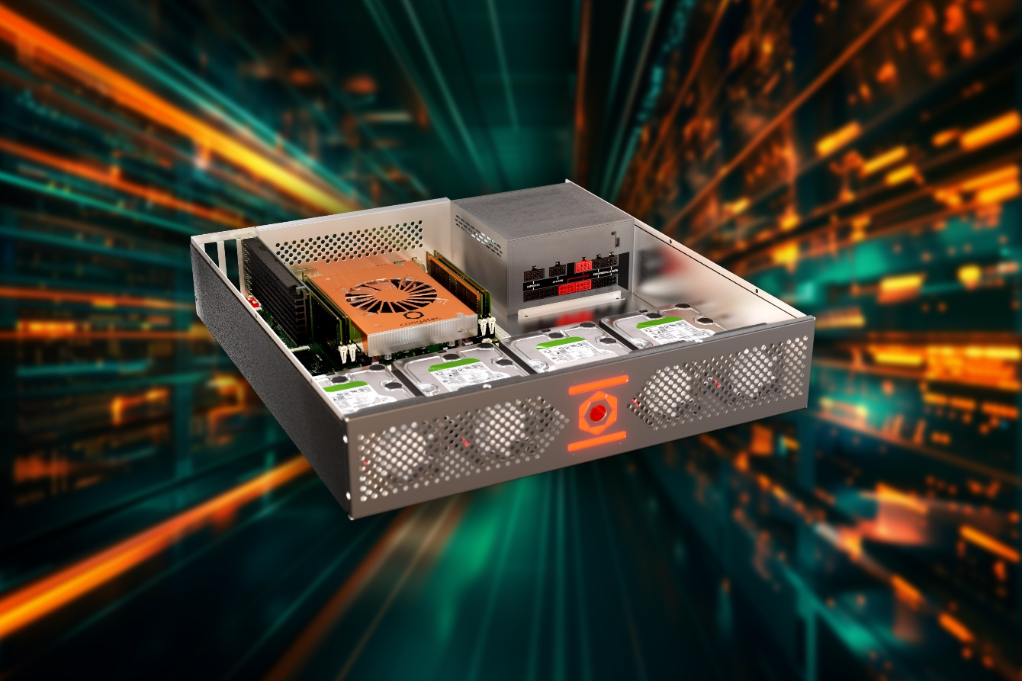

Deggendorf and Freyung, Germany, April 9th, 2024: congatec and Thomas-Krenn.AG, two powerhouses for embedded and edge systems and servers, have joined forces in a new collaboration: The two companies are developing an embedded server with special security features to meet EU requirements. And thanks to its modular design, the system will be upgradable long into the future.

The IT providers unveiled the new, yet to be named µATX server at the “Embedded World” trade fair in Nuremberg today. At the heart of the server is a conga-HPC/sILH Computer-on-Module from congatec. Featuring Intel Xeon D1800 and D2800 processors, the module is based on the COM-HPC Server standard by the PICMG (PCI Industrial Computer Manufacturers Group). With a standardized interface to the carrier board, the modular system can be upgraded with new modules in less than 30 minutes – even across processor generations. This rapid upgradability is critical for ensuring the system remains future-proof and is fit for long-term use – important in terms of environmental and financial sustainability, as well as for providing users with the necessary planning certainty for extended lifecycles.

Typical users are expected to come from the industrial, automotive, security, transport, and logistics sectors. In addition, the security-hardened servers are also suitable for critical infrastructure providers and operators. Use cases range from high-performance image processing in quality control, software deployment, and IT/OT firewalls, to the control of complex machines. The servers’ extended hardware availability and industrial design with support for temperature ranges from -40°C to 85°C are major benefits for these use cases.

Ready for EU security directive NIS-2 – with offline AI
Most system components will be produced in Germany or Europe – important beyond sustainability as local production is a necessary requirement for the system’s security features. Among the components supplied by German manufacturers are field programmable gate arrays (FPGAs); the software is also provided by a domestic supplier. The system is therefore ready for EU Network and Information Security Directive NIS-2, which is already in force and must be transposed into German law by October 2024. Because of the high level of security hardening, congatec and Thomas-Krenn are also planning to integrate an offline generative AI solution.

Local production is important not just in view of strained supply chains and potential regulations requiring it. The short transport routes are as critical for the system’s low environmental footprint as its long lifecycles. Final assembly will take place at Thomas-Krenn in Freyung, some 70 km from congatec’s headquarters in Deggendorf. Development is still underway with completion currently scheduled for October 2024. Final pricing has not yet been determined, but based on current raw material prices, the system is expected to sell in the Thomas-Krenn web shop for less than EUR 2,000 in the standard configuration.

Proven teamwork
“The embedded server congatec and Thomas-Krenn unveiled today is a milestone success, integrating cutting-edge yet proven technology into a highly secure system. The geographical proximity of the two companies may just be a coincidence, but their skills complement each other perfectly,” says Dominik Reßing, CEO of congatec GmbH. Christoph Maier, CEO of Thomas-Krenn.AG, adds: “The success of our low-energy servers (LES) is rooted in an earlier collaboration with congatec. We know and appreciate each other’s technology, quality standards, and processes. We are therefore absolutely certain that our joint effort will bring an extremely attractive system to the market.”

Technical specifications of the embedded Server-on-Module from congatec are already available at: https://www.congatec.com/en/ecosystems/com-hpc-server-ecosystem/

Further information about the COM-HPC Server standard is available at:
https://www.congatec.com/en/technologies/com-hpc/

* * *

About Thomas-Krenn.AG
Thomas-Krenn.AG is one of the largest manufacturers of custom server and storage systems in Germany. Since 2002, the company has been supplying end users, resellers, and data center operators with high-quality hardware built-to-order. The company prides itself on delivering the highest service quality across hardware development, contract manufacturing, product finishing, and logistics. As a custom solutions provider, Thomas-Krenn.AG is a reliable partner for industry, system houses, service providers, and medium-sized end customers from every sector. The company’s solutions meet the highest DIN EN ISO 14001 environmental sustainability standards. All systems are produced at the Freyung site in Germany, where the company currently employs around 200 people. Together with partner company EXTRA Computer GmbH, Thomas-Krenn.AG is one of the largest manufacturers of server and storage hardware in Germany.

About congatec
congatec is a rapidly growing technology company focusing on embedded and edge computing products and services. The high-performance computer modules are used in a wide range of applications and devices in industrial automation, medical technology, robotics, telecommunications and many other verticals. Backed by controlling shareholder DBAG Fund VIII, a German midmarket fund focusing on growing industrial businesses, congatec has the financing and M&A experience to take advantage of these expanding market opportunities. congatec is the global market leader in the computer-on-modules segment with an excellent customer base from start-ups to international blue chip companies. More information is available on our website at www.congatec.com or via LinkedIn, X (Twitter) and YouTube.

Reader enquiries:
congatec
Phone: +49-991-2700-0
info@congatec.com
www.congatec.com

Press contact congatec:
congatec
Christof Wilde
Phone: +49-991-2700-2822
christof.wilde@congatec.com

Press contact agency:
Publitek GmbH
Julia Wolff
+49 (0)4181 968098-18
julia.wolff@publitek.com
Bremer Straße 6
21244 Buchholz

Please send print publications to:
Publitek GmbH
Diana Penzien
Bremer Straße 6
21244 Buchholz

Intel, the Intel logo, and other Intel marks are trademarks of Intel Corporation or its subsidiaries.

