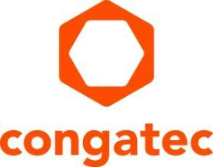
Press release

embedded world preview: congatec presents numerous new high-performance Computer-on-Modules

Newly integrated IIoT capabilities create added value

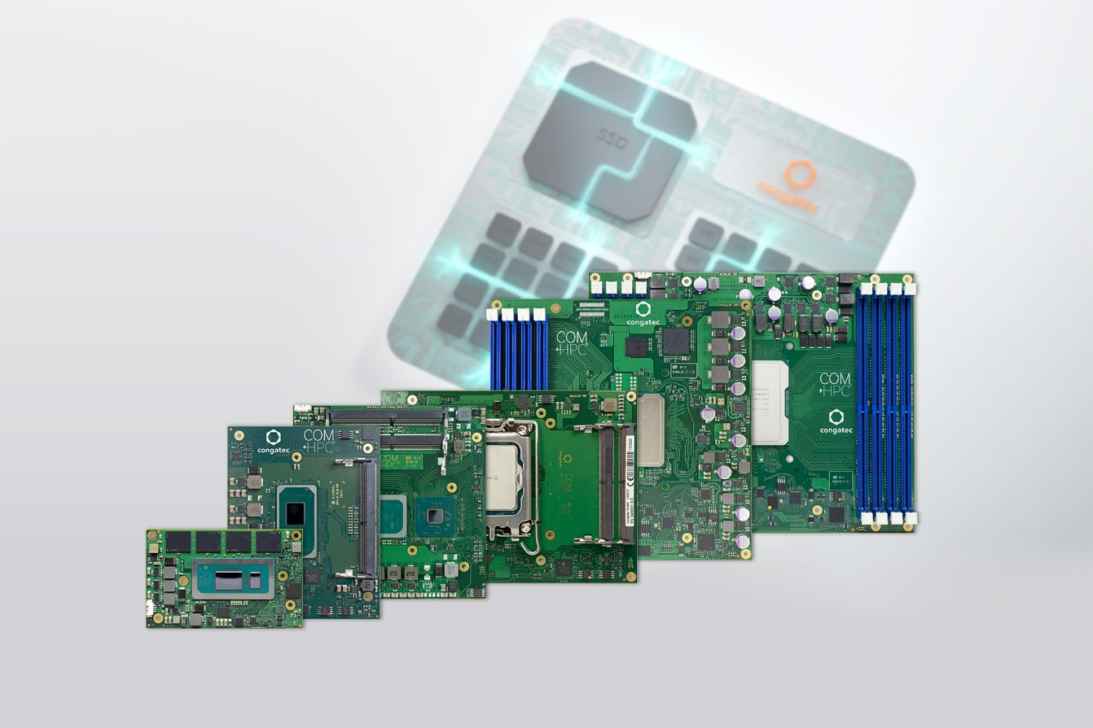

Deggendorf, Germany, 15. February 2024 * * * congatec – a leading vendor of embedded and edge computing technology – will showcase numerous new Computer-on-Modules at embedded world (Hall 3, Booth 241). These innovations include new Intel Core Ultra processor-based modules with integrated AI, additionally premieres based on innovative low-power as well as high-performance x86 processor technology will also be featured. The presentations will focus on increased performance, energy efficiency, and integrated advanced IIoT- and security functions, which have not been part of any existing Computer-on-Module (COM) offering before now. These will significantly increase the application readiness of COMs and contribute to the particularly efficient and reliable development of modern, multifunctional, and comprehensively connected embedded and IIoT devices and differentiate congatec's offering from alternative procurement options.

" IIoT presents OEMs with major challenges, which we, as a Computer-on-Modules supplier, are now addressing with a significantly expanded range of functions of our COM-HPC, COM Express, SMARC and Qseven-based modules. For example, module-integrated hypervisor technology and IIoT functionality makes it easier for solution providers to enrich their applications, bringing increased functionalities without having to develop or integrate them themselves. We will highlight the added value we offer OEM customers through these newly created functionalities at embedded world," explains Tim Henrichs, vice president marketing at congatec.

Embedded systems from OEMs must cover significantly more functionalities to meet all digitalization and IIoT connectivity requirements. congatec addresses these high demands on OEM solutions with its in-house hypervisor technologies and edge IoT functionalities, among other things. The advantages of the seamless integration of this range of solutions into the extended feature set of Computer-on-Modules will be presented by congatec for the first time at embedded world.

The expanded IIoT functions for Computer-on-Modules, are the logical consequence of the company's value-added strategy: As one of the world's leading embedded and edge computing brands in the field of Computer-on-Modules, congatec is ultimately a pioneer when it comes to extended functions and services for the most simplified integration of COM Express, COM-HPC, SMARC and Qseven-based modules. Its high-performance ecosystem offers sophisticated cooling solutions optimized for the individual modules, carrier boards for easy evaluation and application design as well as accompanying software support and individual integration services. Moreover, congatec’s testing and design services save OEMs addition time and work. All this makes the integration of modules easier and more efficient and offers engineers a high level of design security. Customers benefit from faster time-to-market and can therefore master the ever-shorter innovation cycles in the best possible way.

In addition to all functional areas from the processor and form factor functions, congatec modules offer a comprehensive efficiency and convenience for OEMs. The newly integrated virtualization, digitalization and security functions set a new benchmark in terms of the range of capabilities of application-ready Computer-on-Modules, especially for real-time IIoT applications.

Further information on the new presentations can be found on congatec's landing page for embedded world, which will be updated on a regular basis:
https://www.congatec.com/en/congatec/events/congatec-at-embedded-world-2024/

* * *
About congatec
congatec is a rapidly growing technology company focusing on embedded and edge computing products and services. The high-performance computer modules are used in a wide range of applications and devices in industrial automation, medical technology, robotics, telecommunications and many other verticals. Backed by controlling shareholder DBAG Fund VIII, a German midmarket fund focusing on growing industrial businesses, congatec has the financing and M&A experience to take advantage of these expanding market opportunities. congatec is the global market leader in the Computer-on-Modules segment with an excellent customer base from start-ups to international blue chip companies. More information is available on our website at www.congatec.com or via LinkedIn, X (Twitter) and YouTube.

Please make a note of the press conference on all the latest news about congatec on April 9th from 2 - 2:30pm in the NCC east. An invitation will follow shortly. Please contact us directly if you are interested in joining the press conference and/or a one-to-one meeting at the stand.

Reader enquiries:
congatec
Phone: +49-991-2700-0
info@congatec.com
www.congatec.com

Press contact congatec:
congatec
Christof Wilde
Phone: +49-991-2700-2822
christof.wilde@congatec.com

Press contact agency:
Publitek GmbH
Julia Wolff
+49 (0)4181 968098-18
julia.wolff@publitek.com
Bremer Straße 6
21244 Buchholz
Germany

Please send print publications to:
Publitek GmbH
Diana Penzien
Bremer Straße 6
21244 Buchholz
Germany
Intel, the Intel logo, and other Intel marks are trademarks of Intel Corporation or its subsidiaries.

